Fill in the Blanks | Finding HCF and LCM Using Venns

Numbers | Prime Factors | Venn Diagram | HCF | LCM
$$45$$ | $$3×3×5$$ | 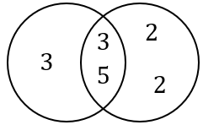 | $$3×5$$  $$=15$$ | $$3×3×5$$  $$×2×2$$  $$=180$$
$$60$$ | $$2×2×3×5$$
$$24$$ | $$2×2×2×3$$ | 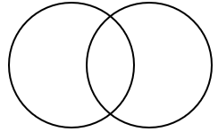
$$30$$ | $$2×3×5$$
$$35$$
$$50$$
$$36$$
$$42$$
$$60$$
$$72$$
 |  | 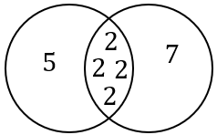
 |  |  | $$18$$ | $$216$$

