Completing Distance-Time Graphs
(a) | (b) | (c)
A delivery driver sets off from the depot to deliver a parcel. | Karen sets of on her bike to visit a friend. A graph showing her journey is shown. | A bus travels from Manchester to London, a distance of 200 miles.
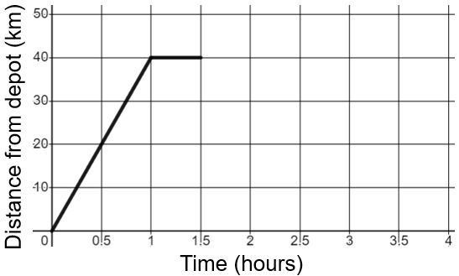 | 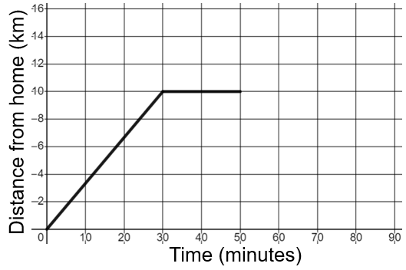 | 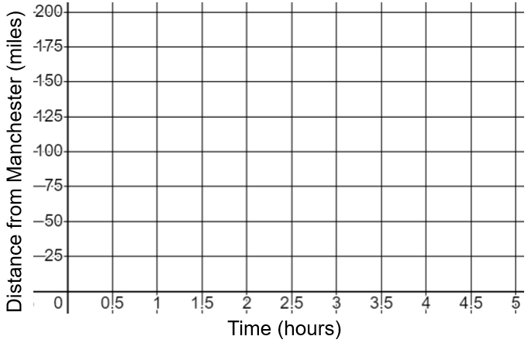
(a) Calculate the speed the driver travels at over the first part of the journey.  (b) How long does the driver stop for while delivering the parcel?  (c) The driver returns to the depot at a constant speed of 20 km/h. Complete the graph.  (d) How far has the delivery driver travelled in total? | (a) At what speed does Karen ride during the first stage of her journey?  (b) How far away from home is Karen when she stops for a rest?  (c) After a rest, Karen continues on to her friend’s house, which is 16 km away from her home. She travels at 12 km/h. Complete the graph. | (a) The bus sets off and travels at 50 mph for 90 minutes. It then stops at the services for 30 minutes, before setting off again. The bus continues its journey, again at 50 mph, for the next two hours. It then gets stuck in slow-moving traffic, travelling the last 25 miles in one hour. Draw a distance-time graph to represent this journey.  (b) Calculate the bus’s average speed across the whole journey.

