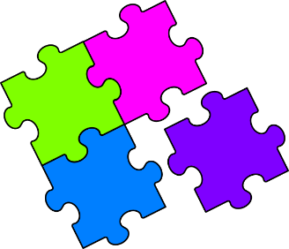
Match-Up
Exact Trigonometric Ratios

1 | $$\tan{45}$$ |  | 6 | $$\sin{60}$$ |  | 11 | $$4\cos{0}$$
2 | $$\sin{30}$$ |  | 7 | $$\tan{30}$$ |  | 12 | $$\sin{30}\cos{30}$$
3 | $$\cos{45}$$ |  | 8 | $$4\cos{60}$$ |  | 13 | $$2\tan{45}\tan{60}$$
4 | $$\sin{0}$$ |  | 9 | $$2\sin{45}$$ |  | 14 | $$\frac{\tan{30}}{\tan{60}}$$
5 | $$\tan{60}$$ |  | 10 | $$3\sin{90}$$ |  | 15 | $$\frac{\tan{30}\cos{45}}{\sin{60}}$$
A | $$0$$ |  | F | $$\frac{\sqrt{3}}{4}$$ |  | K | $$1$$
B | $$\frac{1}{3}$$ |  | G | $$\frac{\sqrt{2}}{2}$$ |  | L | $$\frac{\sqrt{2}}{3}$$
C | $$\sqrt{3}$$ |  | H | $$2$$ |  | M | $$\frac{1}{2}$$
D | $$4$$ |  | I | $$2\sqrt{3}$$ |  | N | $$3$$
E | $$\frac{\sqrt{3}}{3}$$ |  | J | $$\sqrt{2}$$ |  | P | $$\frac{\sqrt{3}}{2}$$

1 | 2 | 3 | 4 | 5 | 6 | 7 | 8 | 9 | 10 | 11 | 12 | 13 | 14 | 15

