Area and Perimeter Using Pythagoras

Find the area and perimeter of each of these right-angled triangles:
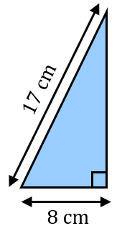
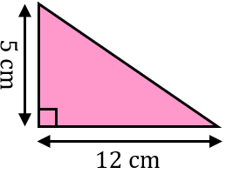
(a) (b)

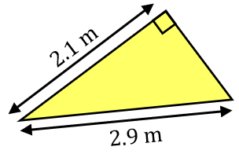
(c)

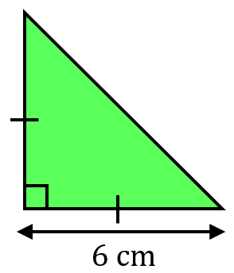
Find the area and perimeter of each of these right-angled triangles, giving your answers to 1 decimal place.
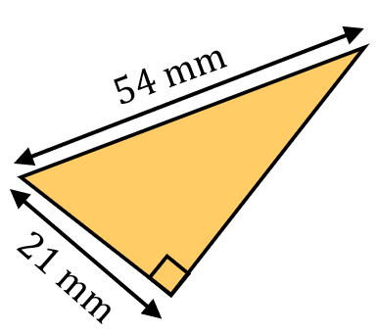
(a) (b)

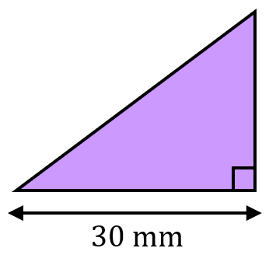
(a) The area of this triangle is $600 {mm}^{2}$. Find the perimeter of the triangle.

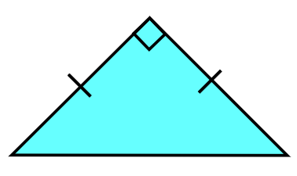
(b) The area of this triangle is $24.5 {cm}^{2}$. Find the perimeter of the triangle.

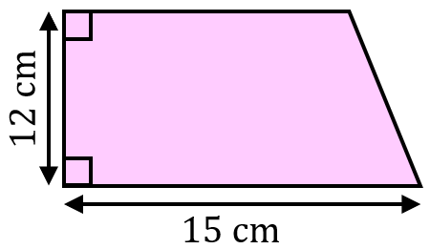
The area of the trapezium is ${120 cm}^{2}$. Find the perimeter of the trapezium.

Area and Perimeter Using Pythagoras

Find the area and perimeter of each of these right-angled triangles:
(a) (b)

(c)

Find the area and perimeter of each of these right-angled triangles, giving your answers to 1 decimal place.
(a) (b)

(a) The area of this triangle is $600 {mm}^{2}$. Find the perimeter of the triangle.

(b) The area of this triangle is $24.5 {cm}^{2}$. Find the perimeter of the triangle.

The area of the trapezium is ${120 cm}^{2}$. Find the perimeter of the trapezium.

