Constructing Triangles
(a) | (b) | (c)
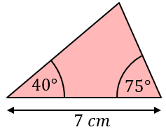  Construct this triangle using a ruler and protractor. | 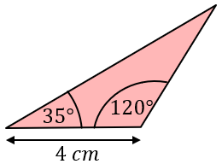  Construct this triangle using a ruler and protractor. | 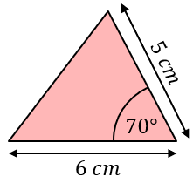  Construct this triangle using a ruler and protractor.
(d) | (e) | (f)
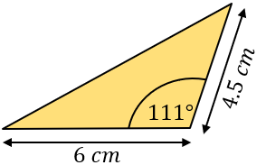  Construct this triangle using a ruler and protractor. | 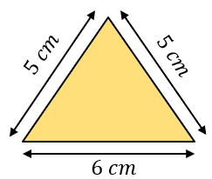  Construct this triangle using a ruler and compasses. | 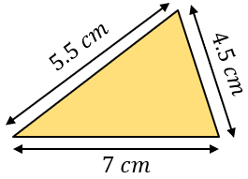  Construct this triangle using a ruler and compasses.

