Area of a Parallelogram

Find the area of each of these parallelograms on these ${cm}^{2}$ grids.
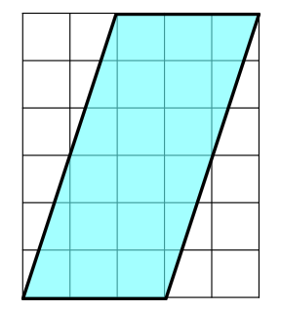
(a) (b)
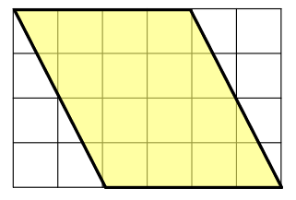

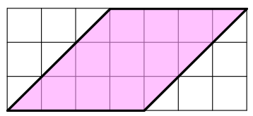
(c)

Calculate the area of each of these parallelograms.
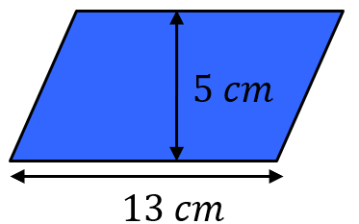
(a) (b)
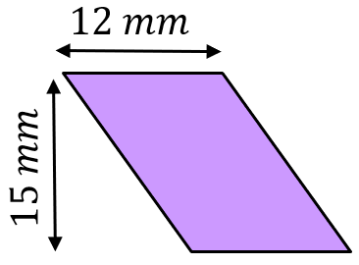

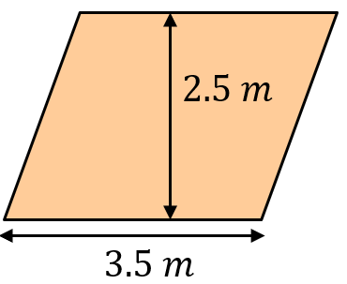
(c)
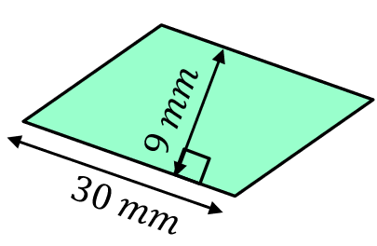
(d)

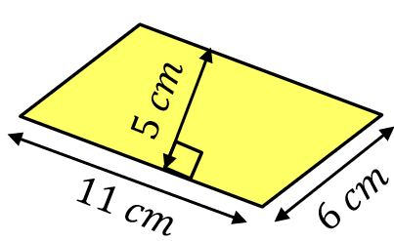
(e) (f)
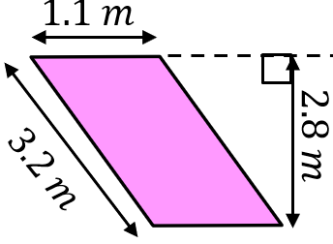

Find the missing measurements in each of these parallelograms, given their area.
(a) $Area=42 {cm}^{2}$ (b) $Area=67.5 {cm}^{2}$
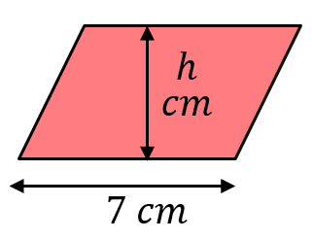
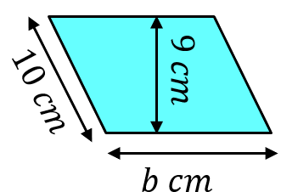

Area of a Parallelogram

Find the area of each of these parallelograms on these ${cm}^{2}$ grids.
(a) (b)

(c)

Calculate the area of each of these parallelograms.
(a) (b)

(c)
(d)

(e) (f)

Find the missing measurements in each of these parallelograms, given their area.
(a) $Area=42 {cm}^{2}$ (b) $Area=67.5 {cm}^{2}$

