Crack the Code | Forming and Solving Equations

A | The area is $138 {cm}^{2}$  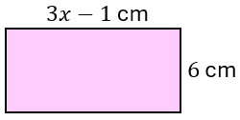 | B | 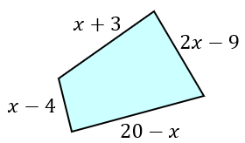  The perimeter is $43 cm$. All lengths are in $cm$.
C | 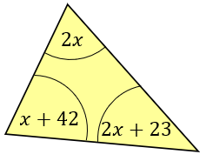 | D | 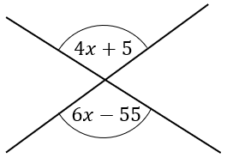
E | 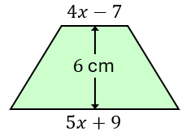  The area is $343.5 {cm}^{2}$. All lengths are in $cm$. | F | A cuboid has dimensions of $5$ cm, $3.6$ cm and $(5+3x)$ cm. The volume of the cuboid is $846 {cm}^{3}$.
G | 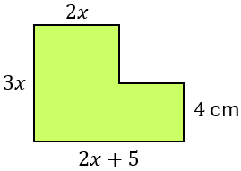  The area is $236 {cm}^{2}$. All lengths are in $cm$. | H | The shape is a rhombus.  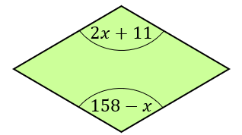
I | The total surface area is $343.6 {cm}^{2}$.  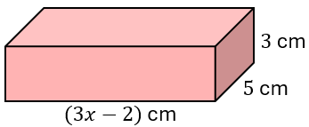 | J | The two shapes have equal areas.  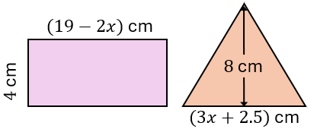
K | Here are four numbers:  $x, x+2, x+7$ and $170$.  The mean of the four numbers is twice the mean of the first three numbers. | L | The area of the trapezium is twice the area of the triangle. All lengths are in $cm$.  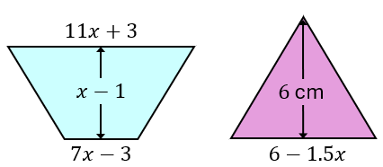
In each question, form and solve an equation in $x$. To get the three-digit code, add all your solutions together.

