Circumference of a Circle

Find the circumference of each circle to 1 decimal place.
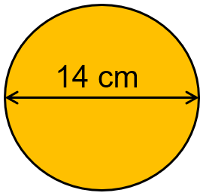
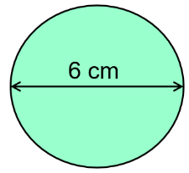
(a) (b)

(c) A circle with a diameter of 40 mm
(d) A ferris wheel with diameter 30.5 m

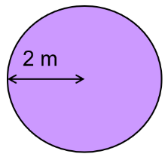
Find the circumference of each circle to 1 decimal place
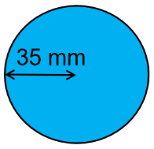
(a) (b)

(c) A circle with radius 14 cm
(d) A moon crater with radius 137 km

Work out the length of the arc and the perimeter of these shapes.
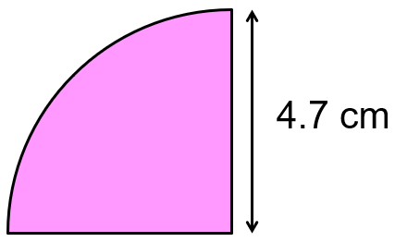
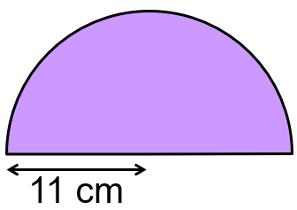
(a) (b)

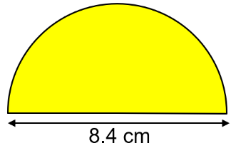
(c)

Find the perimeter of these shapes.
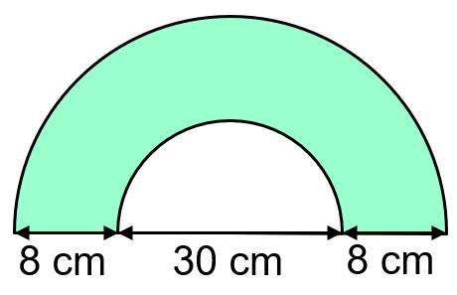
(a)

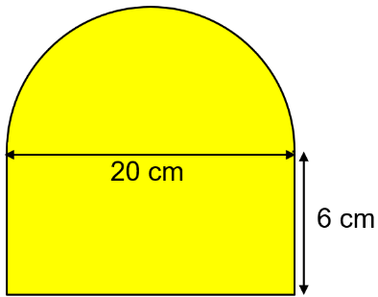
(b)

Circumference of a Circle

Find the circumference of each circle to 1 decimal place.
(a) (b)

(c) A circle with a diameter of 40 mm
(d) A ferris wheel with diameter 30.5 m

Find the circumference of each circle to 1 decimal place
(a) (b)

(c) A circle with radius 14 cm
(d) A moon crater with radius 137 km

Work out the length of the arc and the perimeter of these shapes.
(a) (b)

(c)

Find the perimeter of these shapes.
(a)

(b)

