Crack the Code | Pythagoras’ Theorem

A | 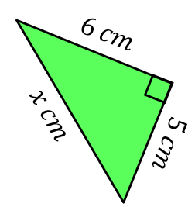 | B | 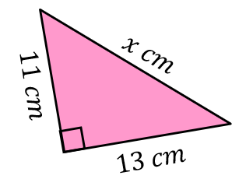 | C | 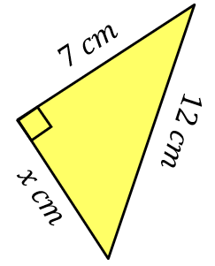
D | 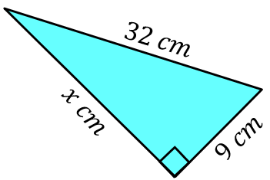 | E | 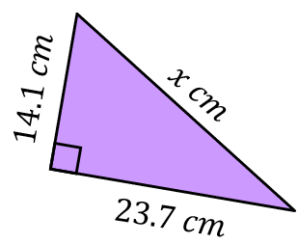 | F | 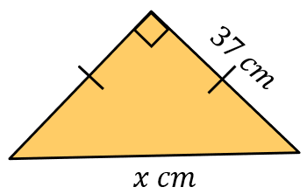
G | 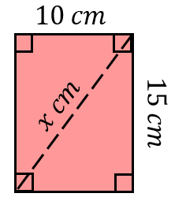 | H | 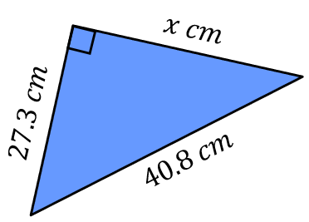 | I | Find the length of the diagonal of a square of side length $20 cm$.
J | 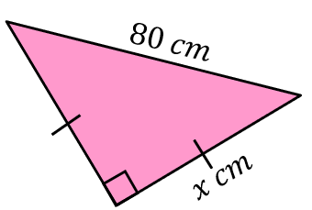 | K | Find the length of the diagonal of a rectangle of length $25 cm$and width $18 cm$. | L | 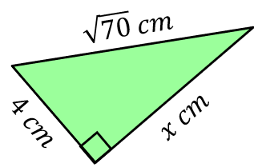
M | 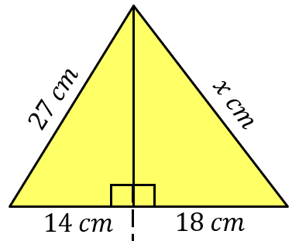 | N | 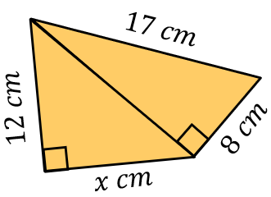 | O | 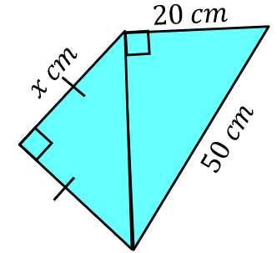
Round each of your answers to 1 decimal place. To get the three-digit code, add together all your answers and round to the nearest integer.

