Area and Perimeter Revision
(a) | (b) | (c) |  | (d)
Find the area.  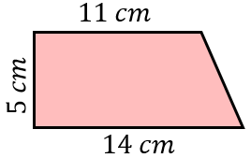 | Find the perimeter of the triangle.  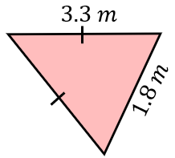 | The area of the triangle is $20 {cm}^{2}$. Find the area of the rectangle.  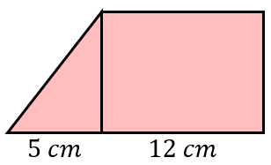 |  | 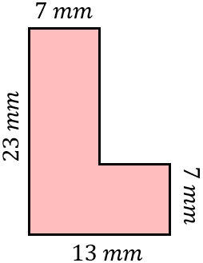  Find the perimeter.
(e) | (f) | (g) |  | (h)
Find the area of the semi-circle to 1 decimal place.  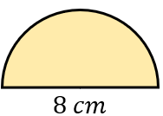 | Find the perimeter to 3 significant figures.  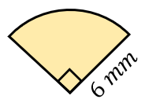 | Find the perimeter to 1 decimal place.  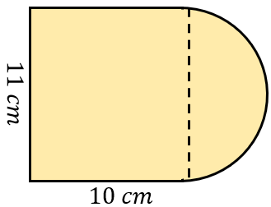 |  | Find the area, giving your answer to 1 decimal place.  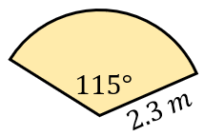
(i) | (j) |  | (k)
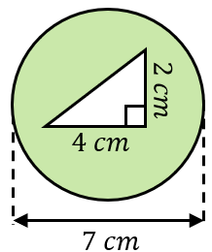  Work out the area of the shaded region. | The area of the sector is $24π {cm}^{2}$. Find the perimeter of the sector in terms of $π$.  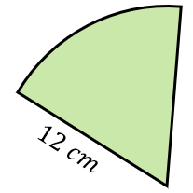 |  | 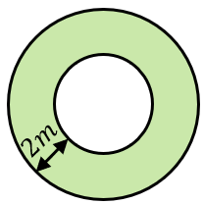  A circular lawn is surrounded by a path of constant width $2 m$. The area of the path is $30π m^{2}$. Find the area of the lawn in terms of $π$.

