Constructing Loci with Bisectors
(a) | (b) | (c)
Complete the perpendicular bisector of the line AB and shade the region which is closer to B than to A  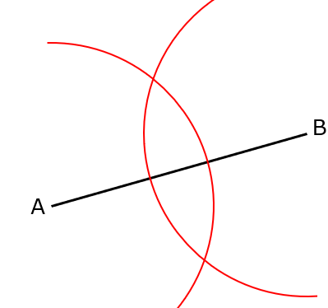 | Construct the perpendicular bisector of the line CD and shade the region that is closer to C than to D  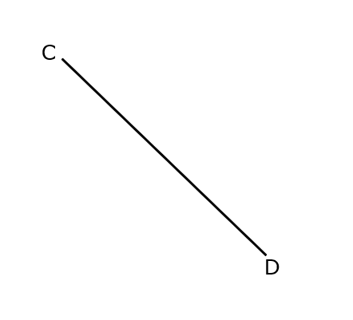 | Shade the region that is closer to F than it is to E
(d) | (e) | (f)
Complete the bisector of the angle ABC and shade the region which is closer to the line AB than to the line BC  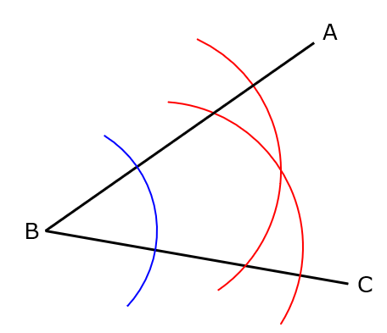 | Construct the bisector of the angle DEF and shade the region which is closer to the line EF than to the line DE  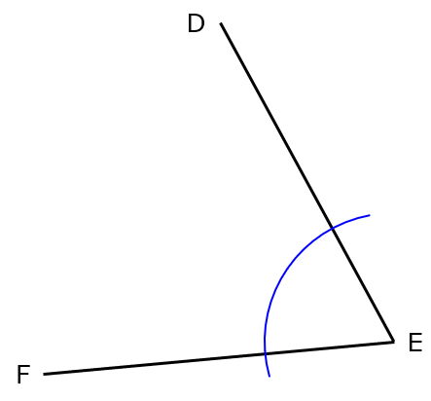 | Shade the region that is closer to the line GH than it is to the line HJ

