Harder Similar Areas and Volumes

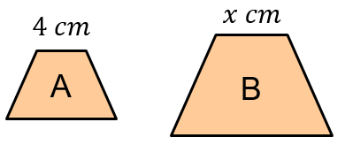
(a) The area of A is $20 {cm}^{2}$and the area
of B is $180 {cm}^{2}$. Find $x$.
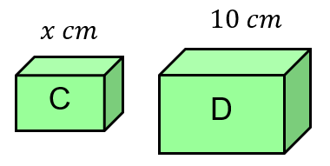
(b) The volume of C is $5 {cm}^{3}$and the volume of D is $320 {cm}^{2}$. Find $x$.

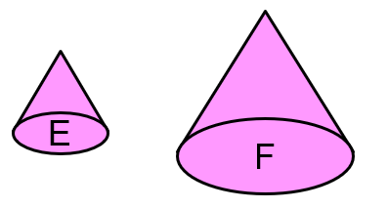
(c) The surface area of E is $15 {cm}^{2}$ and the surface area of F is $60 {cm}^{2}$. If the volume of E is $27 {cm}^{3}$, find the volume of F.
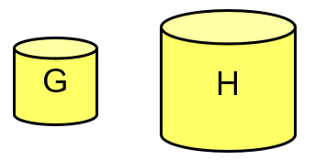

(d) The volume of G is $4 {cm}^{3}$ and the volume of H is $171.5 {cm}^{3}$. If the surface area of H is $122.5 {cm}^{2}$, find the surface area of G.

(e) If a painting with area of $220 {cm}^{2}$ has a diagonal length of $21 cm$, what will be the diagonal length of a similar painting with area $350 {cm}^{2}$?

(f) It takes 5.6 litres of paint to paint a tower that is 3 m high. What is the tallest similar tower that can be painted with 8 litres of paint?

(g) A bronze statue has a mass of 300g and a height of 9 cm. A similar statue has a mass of 2 kg. What is its height?
Harder Similar Areas and Volumes

(a) The area of A is $20 {cm}^{2}$and the area
of B is $180 {cm}^{2}$. Find $x$.
(b) The volume of C is $5 {cm}^{3}$and the volume of D is $320 {cm}^{2}$. Find $x$.

(c) The surface area of E is $15 {cm}^{2}$ and the surface area of F is $60 {cm}^{2}$. If the volume of E is $27 {cm}^{3}$, find the volume of F.

(d) The volume of G is $4 {cm}^{3}$ and the volume of H is $171.5 {cm}^{2}$. If the surface area of H is $122.5 {cm}^{3}$, find the surface area of G.

(e) If a painting with area of $220 {cm}^{2}$ has a diagonal length of $21 cm$, what will be the diagonal length of a similar painting with area $350 {cm}^{2}$?

(f) It takes 5.6 litres of paint to paint a tower that is 3 m high. What is the tallest similar tower that can be painted with 8 litres of paint?

(g) A bronze statue has a mass of 300g and a height of 9 cm. A similar statue has a mass of 2 kg. What is its height?

