Area and Perimeter of Sectors

Find the area of each of these sectors.
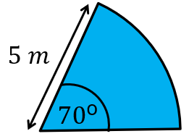
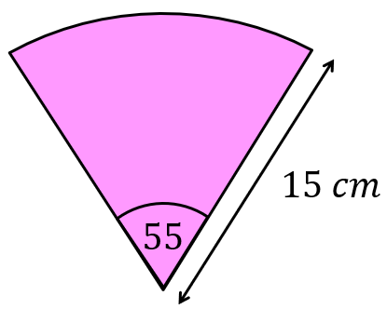
(a) (b)

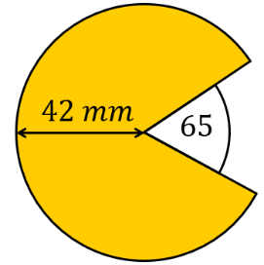
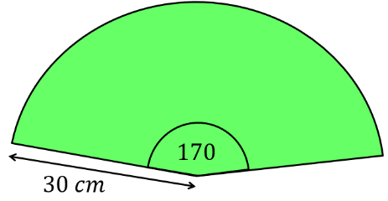
(c) (d)

Find the arc length and perimeter of each of these sectors.
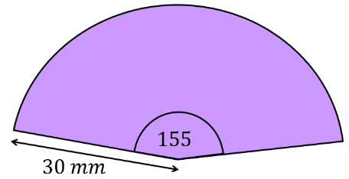
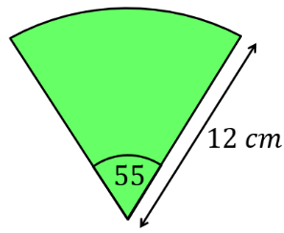
(a) (b)

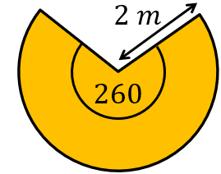
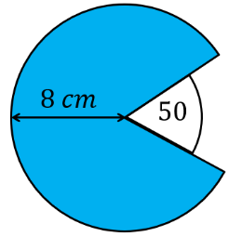
(c) (d)

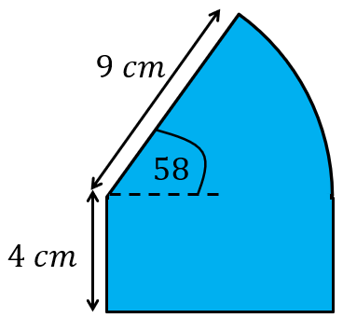
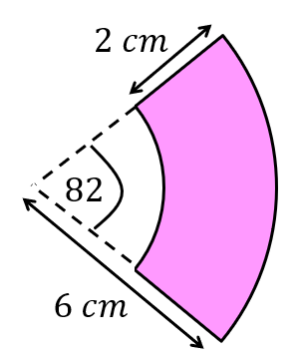
Find the area and perimeter of these shapes.
(a) (b)

(a) A sector has an area of $70{cm}^{2}$ and a radius of $8 cm$. Find its angle.
(b) A sector with angle $75°$ has an area of $30 {cm}^{2}$. Find the radius of the sector.
(c) A sector has a perimeter of $35 cm$ and a radius of $7 cm$. Find its angle.
Area and Perimeter of Sectors

Find the area of each of these sectors.
(a) (b)

(c) (d)

Find the arc length and perimeter of each of these sectors.
(a) (b)

(c) (d)

Find the area and perimeter of these shapes.
(a) (b)

(a) A sector has an area of $70{cm}^{2}$ and a radius of $8 cm$. Find its angle.
(b) A sector with angle $75°$ has an area of $30 {cm}^{2}$. Find the radius of the sector.
(c) A sector has a perimeter of $35 cm$ and a radius of $7 cm$. Find its angle.

