Match-Up | More Gradients of Straight Lines
Find matching pairs of gradients, stating the pairs and their gradients.
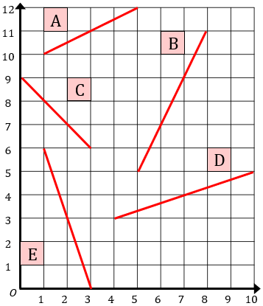 |  | 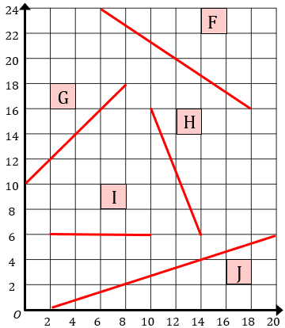
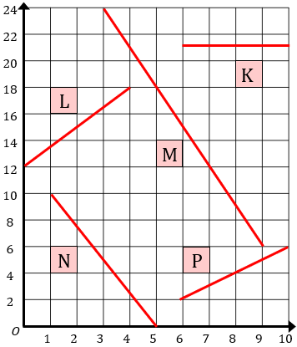 |  | 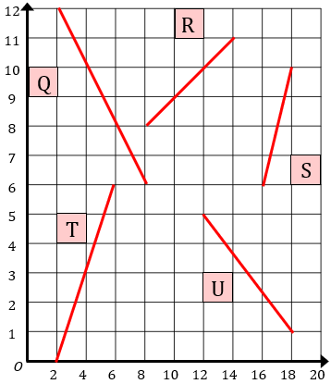

Line 1
Line 2
Gradient

