Match-Up | Loci and Regions
Diagrams are drawn on a centimetre square grid.
1 | 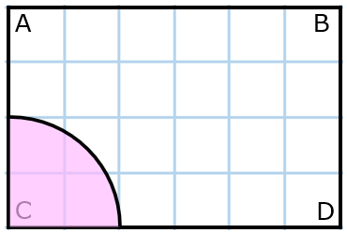 | 5 | 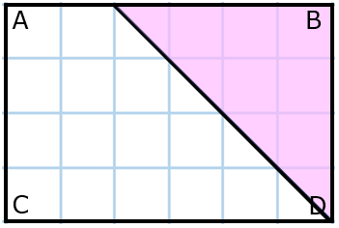 | 9 | 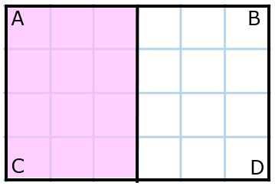
2 | 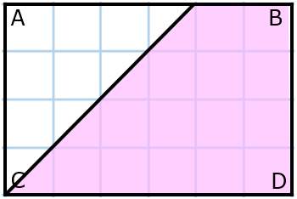 | 6 | 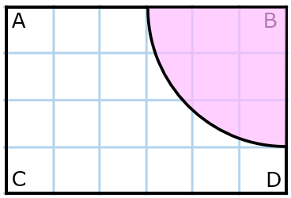 | 10 | 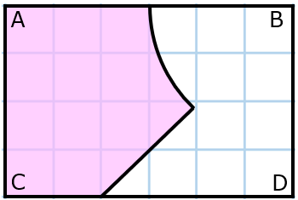
3 | 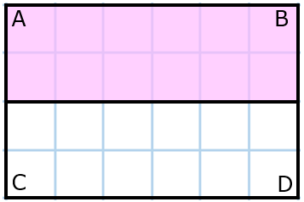 | 7 | 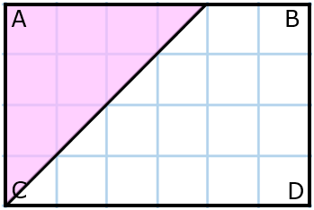 | 11 | 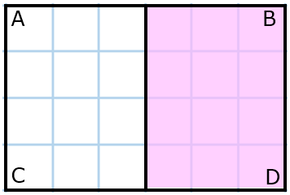
4 | 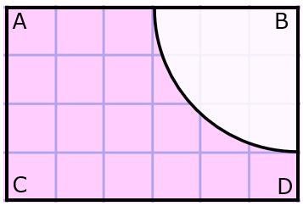 | 8 | 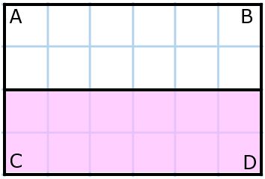 | 12 | 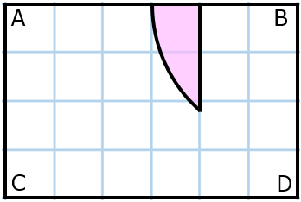
A | The set of points that are closer to D than to B | E | The set of points that is more than 3 cm from B | I | The set of points that are closer to CD than to AC
B | The set of points more than 3 cm from B and closer to AB than BD | F | The set of points that are less than 3 cm from AC | J | The set of points that are less than 3 cm from B
C | The set of points that are closer to AC than to CD | G | The set of points that are less than 2 cm from C | K | The set of points less than 3 cm from B and more than 2 cm from BD
D | The set of points that are closer to D than to C | H | The set of points closer to BD than to CD | L | The set of points that are more than 2 cm from CD

1 | 2 | 3 | 4 | 5 | 6 | 7 | 8 | 9 | 10 | 11 | 12

