Using Map Scales
(a) | (b) | (c)
This map has a scale of $1 cm :10 m$ | This map has a scale of $1 cm :4 km$ | This map has a scale of $2 cm :5 miles$
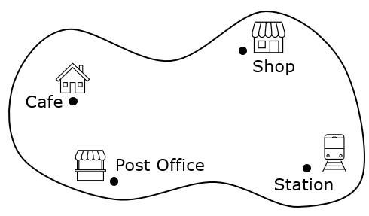 | 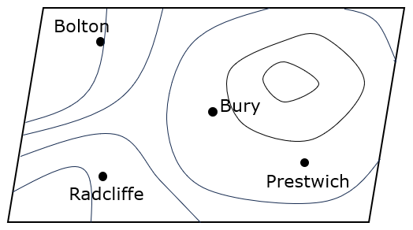 | 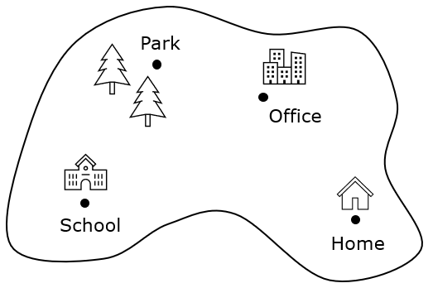
(i) What is the actual distance from the shop to the station? | (i) Find the distance from Prestwich to Radcliffe in km. | (i) What is the actual distance from the office to the school?
(ii) What is the actual distance from the café to the post office? | (ii) Find the distance from Radcliffe to Bury in km. | (ii) What is the actual distance from the school to the park?
(iii) What is the actual distance from the station to the cafe? | (iii) Find the distance from Bolton to Radcliffe in km. | (iii) What is the actual distance from home to the park ?
(iv) Aidan walks from the cafe to the post office and then to the station. How far has he walked in metres? | (iv) A delivery van goes from Bolton to Bury, and then on to Prestwich. How far has the van travelled? | (iv) Fatima travels from home to school, then to the park before returning home again. How far has she travelled?

