Bearings and Scale Diagrams

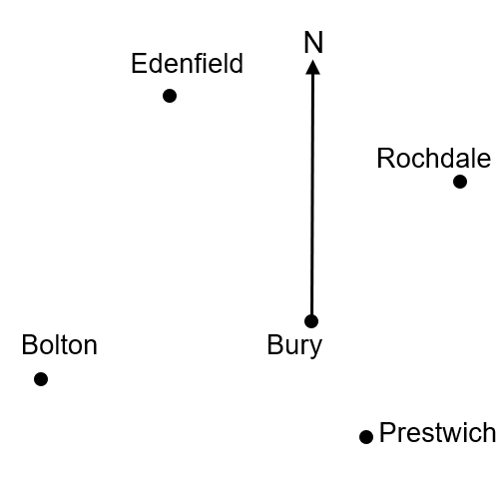
Using a scale of 1 cm to 2 km, find the distance and bearings of the following:
(a) Rochdale from Bury
(b) Prestwich from Bury
(c) Edenfield from Bury
(d) Bolton from Bury

Using the same scale diagram, find the bearing of:
(a) Bury from Edenfield
(b) Bury from Rochdale

A ship sails from a port on a bearing of 100º for 50 km. It then turns and sails on a bearing of 240º for 80 km. Using a scale of 1 cm to 10 km, draw a scale diagram. Find the distance of the ship from the port, and the bearing it must head on to return to the port.

(a) The bearing of B from A is 110º. Find the bearing of A from B.
(b) The bearing of B from A is $x°$. Find the bearing of A from B.

Bearings and Scale Diagrams

Using a scale of 1 cm to 2 km, find the distance and bearings of the following:
(a) Rochdale from Bury
(b) Prestwich from Bury
(c) Edenfield from Bury
(d) Bolton from Bury

Using the same scale diagram, find the bearing of:
(a) Bury from Edenfield
(b) Bury from Rochdale

A ship sails from a port on a bearing of 100º for 50 km. It then turns and sails on a bearing of 240º for 80 km. Using a scale of 1 cm to 10 km, draw a scale diagram. Find the distance of the ship from the port, and the bearing it must head on to return to the port.

(a) The bearing of B from A is 110º. Find the bearing of A from B.
(b) The bearing of B from A is $x°$. Find the bearing of A from B.

