Constructing Loci with Circles
(a) | (b) | (c)
The circle drawn with centre A has radius 2 cm. Shade the region that is less than 2 cm from point A.  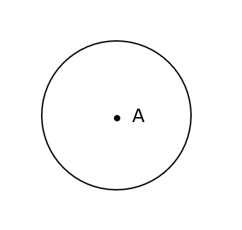 | Draw a circle with centre B and radius 2 cm and shade the region which is more than 2 cm from B. | Shade the region that less than 2.5 cm from point C.  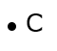
(d) | (e) | (f)
The two circles at points A and B have radii of 1.5 cm. Shade the region which is less than 1.5 cm from the line AB.  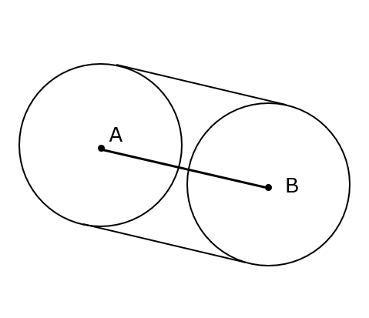 | Draw two circles of radii 2 cm from C and D. Shade the region which is more than 2 cm from the line CD. | Shade the region that is less than 1.5 cm from the line EF.

