Similar Areas and Volumes

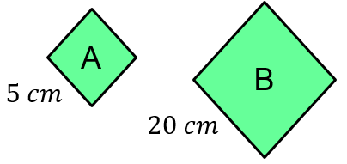

(a) Find the linear scale factor.
(b) Find the area scale factor.
(c) The area of shape A is $15 {cm}^{2}$, find the area of shape B.
(d) The area of shape B is $360 {cm}^{2}$, find the area of shape A.

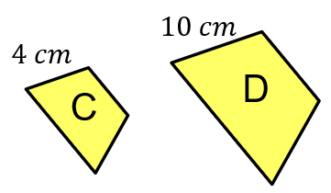

(a) The area of shape C is $12 {cm}^{2}$, find the area of shape D.
(b) The area of shape D is $50 {cm}^{2}$, find the area of shape C.

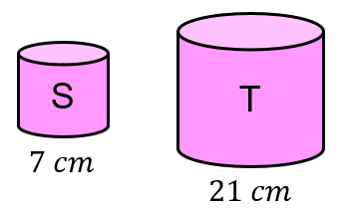

(a) The volume of shape S is $70 {cm}^{3}$, find the volume of shape T.
(b) The volume of shape T is $810 {cm}^{3}$, find the volume of shape S.

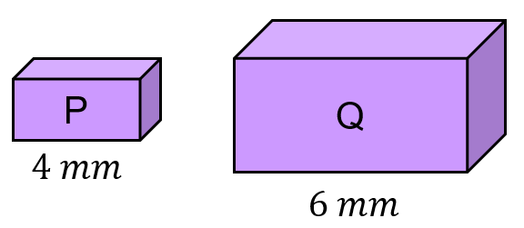

(a) The volume of shape P is $24 {cm}^{3}$, find the volume of shape Q.
(b) The volume of shape Q is $270 {cm}^{3}$, find the volume of shape P.
(c) The surface area of shape P is $110 {cm}^{2}$, find the surface area of shape Q.
(d) The surface area of shape Q is $180 {cm}^{2}$, find the surface area of shape P.
Similar Areas and Volumes

(a) Find the linear scale factor.
(b) Find the area scale factor.
(c) The area of shape A is $15 {cm}^{2}$, find the area of shape B.
(d) The area of shape B is $360 {cm}^{2}$, find the area of shape A.

(a) The area of shape C is $12 {cm}^{2}$, find the area of shape D.
(b) The area of shape D is $50 {cm}^{2}$, find the area of shape C.

(a) The volume of shape S is $70 {cm}^{3}$, find the volume of shape T.
(b) The volume of shape T is $810 {cm}^{3}$, find the volume of shape S.

(a) The volume of shape P is $24 {cm}^{3}$, find the volume of shape Q.
(b) The volume of shape Q is $270 {cm}^{3}$, find the volume of shape P.
(c) The surface area of shape P is $110 {cm}^{2}$, find the surface area of shape Q.
(d) The surface area of shape Q is $180 {cm}^{2}$, find the surface area of shape P.

