Name the Film | Equations of Straight Lines

A | B | C | D | E | F | G | H | I | J | K | L | M
$$x=2$$ | $$x=8$$ | $$y=-4$$ | $$y=-1$$ | $$y=1$$ | $$x=1$$ | $$x=3$$ | $$y=0$$ | $$x=0$$ | $$y=-2$$ | $$y=7$$ | $$x=-4$$ | $$x=4$$
N | O | P | Q | R | S | T | U | V | W | X | Y | Z
$$y=3$$ | $$y=x$$ | $$x=7$$ | $$x=-5$$ | $$y=2$$ | $$x=-3$$ | $$x=5$$ | $$y=-3$$ | $$y=6$$ | $$y=-x$$ | $$x=-2$$ | $$y=5$$ | $$x=-1$$

Find the equations of each of the lines shown and their corresponding letter, then unjumble the letters to find the film:

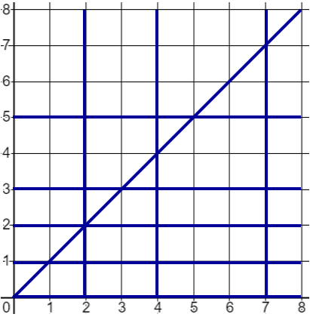 | Equation | Letter | 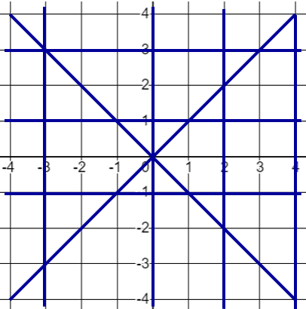 | Equation | Letter

The name of the film is ________________________________________________

