Speed-Time Graphs
(a) | (b) |  | (c)
Find the acceleration.  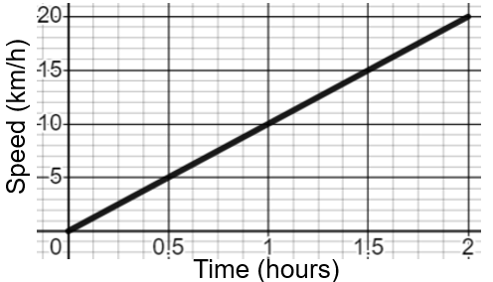 | Find the deceleration.  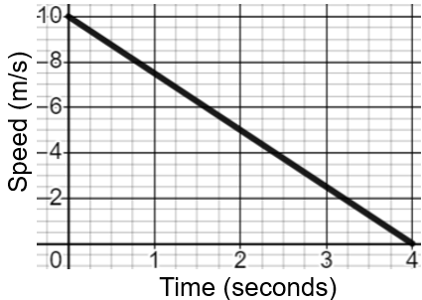 |  | Find the acceleration.  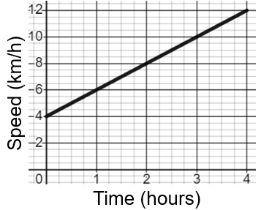
(d) |  | (e)
Describe each step of the journey, stating the values of any acceleration or deceleration.  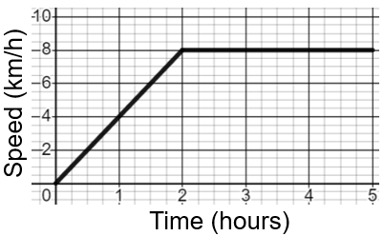 |  | Describe each step of the journey, stating the values of any acceleration or deceleration.  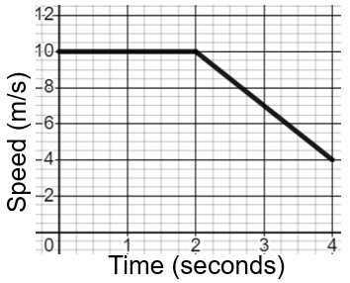
(f) |  | (g)
Describe each stage of the speed-time graph, calculating the values of any acceleration and deceleration.  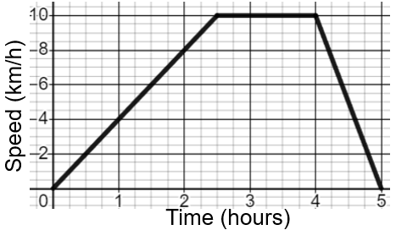 |  | Describe each stage of the speed-time graph, calculating the values of any acceleration and deceleration.  