Tree Diagrams for Independent Events

Ray has cereal or toast for his breakfast. The probability that he has cereal is 0.6. Ray has breakfast on Saturday and Sunday. Complete the tree diagram.
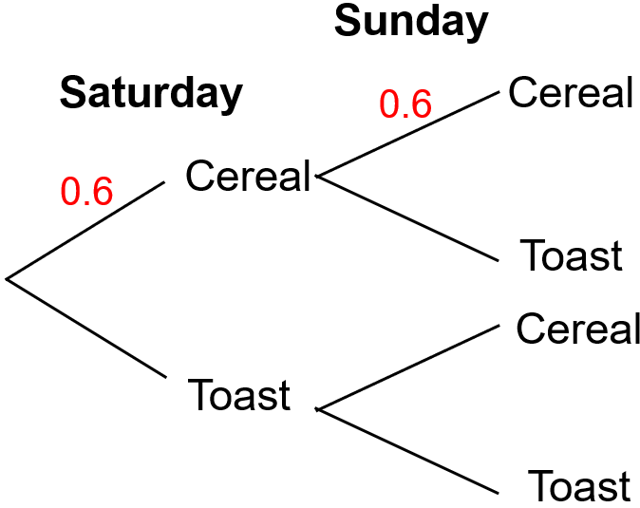

Find the probability that Ray has toast for breakfast on both days.

Zoya throws a biased coin twice. The probability that it lands on heads is 0.55. Represent this with a tree diagram. Find the probability that:
(a) Zoya gets two heads
(b) Zoya gets one of each - head and tail

Joy and Peter both sit a French test. The probability of passing the test is $\frac{2}{5}$. Represent this with a tree diagram. Find the probability that
(a) only one of them passes the test
(b) they both fail the test

The probability that Anna gets up late on a Monday is $\frac{1}{3}$. The probability that she gets up late on a Tuesday is $\frac{1}{4}$. Represent this with a tree diagram. Find the probability that Anna gets up late on at least one of the days.

Jamal plays three games of Monopoly against Iris. The probability that Jamal wins Monopoly is 0.4. Find the probability that Jamal wins at least two of the three games.
Tree Diagrams for Independent Events

Ray has cereal or toast for his breakfast. The probability that he has cereal is 0.6. Ray has breakfast on Saturday and Sunday. Complete the tree diagram.

Find the probability that Ray has toast for breakfast on both days.

Zoya throws a biased coin twice. The probability that it lands on heads is 0.55. Represent this with a tree diagram. Find the probability that:
(a) Zoya gets two heads
(b) Zoya gets one of each - head and tail

Joy and Peter both sit a French test. The probability of passing the test is $\frac{2}{5}$. Represent this with a tree diagram. Find the probability that
(a) only one of them passes the test
(b) they both fail the test

The probability that Anna gets up late on a Monday is $\frac{1}{3}$. The probability that she gets up late on a Tuesday is $\frac{1}{4}$. Represent this with a tree diagram. Find the probability that Anna gets up late on at least one of the days.

Jamal plays three games of Monopoly against Iris. The probability that Jamal wins Monopoly is 0.4. Find the probability that Jamal wins at least two of the three games.

