Perpendicular Bisectors and Angle Bisectors
(a) | (b) | (c)
Complete the perpendicular bisector of the line AB  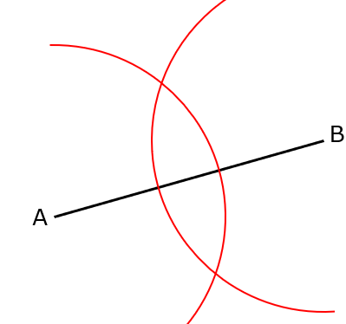 | Construct the perpendicular bisector of the line CD  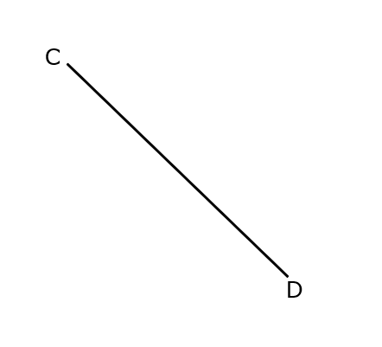 | Construct the perpendicular bisector of the line EF
(d) | (e) | (f)
Complete the bisector of the angle ABC  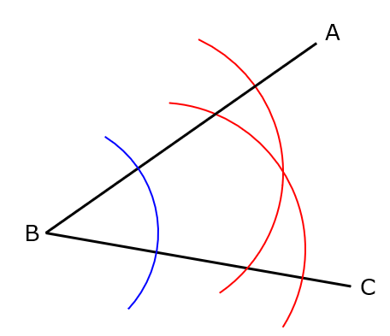 | Construct the bisector of the angle DEF  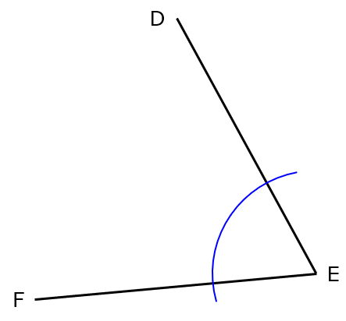 | Construct the bisector of the angle GHJ  