Finding the Length of the Hypotenuse using Pythagoras’ Theorem
(a) Find $x$ to 1 decimal place |  | (b) Find $x$ |  | (c) Find $y$ to 1 decimal place
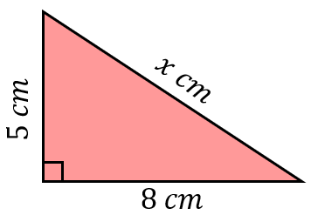 | $$x^{2}=5^{2}+8^{2}$$  $$x^{2}=89$$  $$x=\sqrt{89}$$  $$x=9.4 cm (1 dp)$$ | 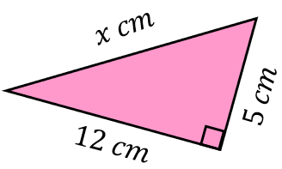 | $$x^{2}=5^{2}+{12}^{2}$$ | 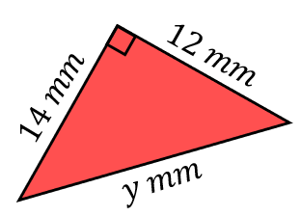 |  | $$y^{2}={12}^{2}+{14}^{2}$$
(d) Find $x$ |  | (e) Find $y$ to 1 decimal place |  | (f) Find $x$ to 1 decimal place
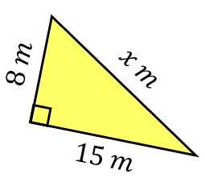 |  | 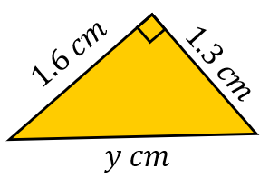 |  | 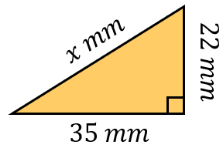
(g) Find$x$ to 1 decimal place |  | (h) Find $y$ |  | (i) Find $y$ to 1 decimal place
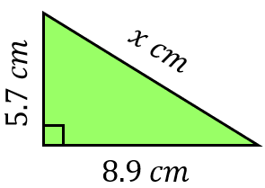 |  | 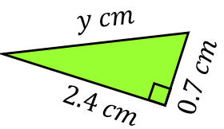 |  | 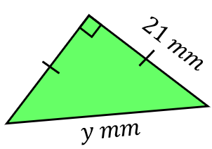
(j) Find $x$, leaving your answer as a surd |  | (k) Find $y$, leaving your answer as a surd |  | (l) Find $x$, leaving your answer as a surd
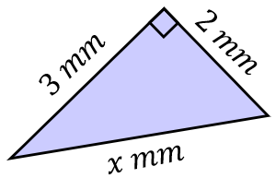 |  | 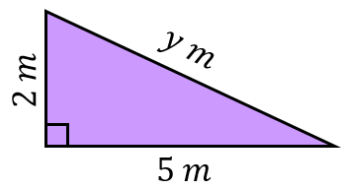 |  | 