Crack the Code | Straight Line Graphs
Answer all the questions, then add your answers together to find the three-digit code
Write down the gradient of the line with equation  $$y=5x-1$$ | Complete the table for $y=2x+3$  $$x$$ 1 2 3  $$y$$ | Write down the coordinates of this point.  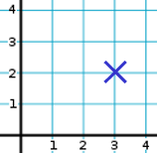 | Write down the y-intercept of the line with equation  $$y=x+10$$ | Write down the gradient of the line with equation  $$y=-x+7$$ | Find the gradient  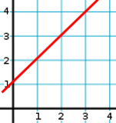
Write down the coordinates of this point.  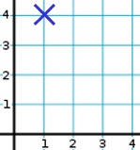 | Find the y-intercept  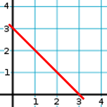 | Write down the gradient of the line with equation  $$y=8+2x$$ | Complete the table for $y=3x-2$  $$x$$ 3 4 5  $$y$$ | The equation of this line is $y=?$  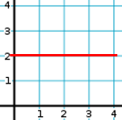 | Write down the y-intercept of the line with equation  $$y=8+5x$$
Find the missing coordinate in the rhombus with vertices (1, 5), (7, 3) and (13, 5) | Write down the y-intercept of the line with equation  $$y=\frac{1}{2}x-1$$ | Find the gradient  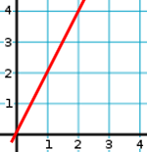 | Find the y-intercept  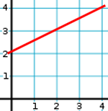 | Complete the table for $y=-x+6$  $$x$$ 1 2 3  $$y$$ | Write down the coordinates of this point.  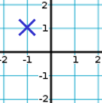
Write down the y-intercept of the line with equation  $$y=2x-5$$ | Complete the table for $y=5x+2$  $$x$$ 1 2 3  $$y$$ | Find the y-intercept  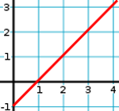 | Write down the gradient of the line with equation  $$y=7x$$ | Find the gradient  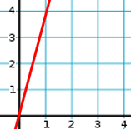 | Three corners of a square are (1, 3), (4, 3) and (1, 6). What are the coordinates of the fourth corner?
Write down the gradient of the line with equation  $$y=-3x-2$$ | Write down the coordinates of this point.  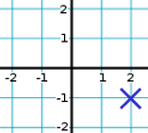 | Write down the y-intercept of the line with equation  $$y=3x+15$$ | Find the gradient | Complete the table for $y=-2x+10$  $$x$$ 2 3 4  $$y$$ | Find the y-intercept  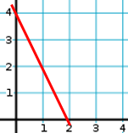
Find the gradient | Two corners of a rectangle are (5, 6) and (7, 12). What are the coordinates of the other two corners? | Complete the table for $x+y=10$  $$x$$ 4 5 6  $$y$$ | Write down the y-intercept of the line with equation  $$y=-x+6$$ | Write down the gradient of the line with equation  $$2y=6x+10$$ | The equation of this line is $x=?$  