Shading Graphical Inequalities
(a) | (b) | (c)
$$y > 1$$  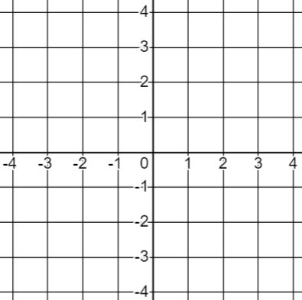 | $$y ≤- 2$$ | $$x<0$$
(d) | (e) | (f)
$$x≥3$$ | $$y≥0$$ | $$x≤-3$$
(g) | (h) | (i)
$$x≥2 and y<1$$ | $$x<-1 and y>3$$ | $$x≤0 and y<0$$
(j) | (k) | (l)
$$x≥-1 and y≥3$$ | $$y≥x and x<2$$ | $$y<-x and y≤-1$$

