Measuring and Drawing Bearings

Measure the bearing of B from A.
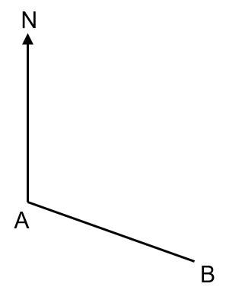
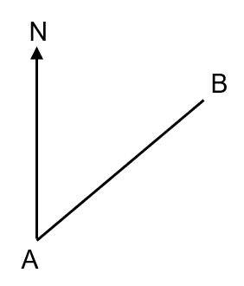
(a) (b)

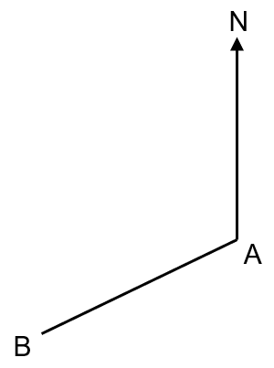
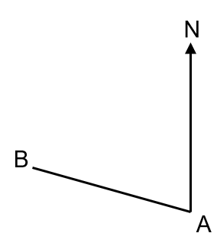
(c) (d)

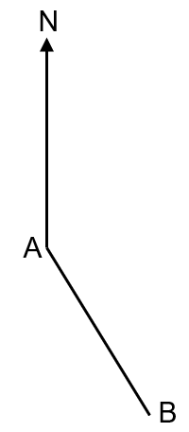

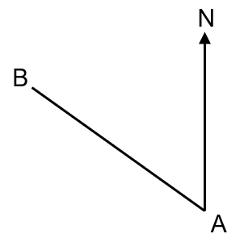
(e) (f)

Draw the following bearings:
(a) A point B on a bearing of 135º from A
(b) A point B on a bearing of 080º from A
(c) A point B on a bearing of 162º from A

Draw the following bearings:
(a) A point B on a bearing of 300º from A
(b) A point B on a bearing of 205º from A
(c) A point B on a bearing of 330º from A
Measuring and Drawing Bearings

Measure the bearing of B from A.
(a) (b)

(c) (d)

(e) (f)

Draw the following bearings:
(a) A point B on a bearing of 135º from A
(b) A point B on a bearing of 080º from A
(c) A point B on a bearing of 162º from A

Draw the following bearings:
(a) A point B on a bearing of 300º from A
(b) A point B on a bearing of 205º from A
(c) A point B on a bearing of 330º from A

