Match-Up
Finding Gradients of Straight Lines

1 | 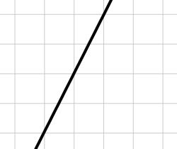 |  | 7 | The line joining $(0, 0)$ and  $$(2, 2)$$ |  | A | $$2$$
 |  |  |  |  |  | B | $$1$$
2 | 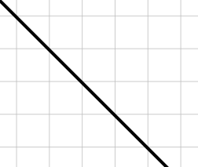 |  | 8 | The line joining $(1, 2)$ and $(3, 10)$ |  | C | $$-\frac{3}{2}$$
 |  |  |  |  |  | D | $$4$$
3 | 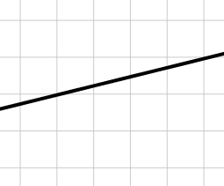 |  | 9 | The line joining $(-2, 0)$ and $(1, 9)$ |  | E | $$-2$$
 |  |  |  |  |  | F | $$\frac{1}{4}$$
4 | 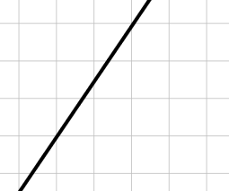 |  | 10 | The line joining $(5, 2)$ and $(-1, -2)$ |  | G | $$-\frac{2}{5}$$
 |  |  |  |  |  | H | $$\frac{3}{2}$$
5 | 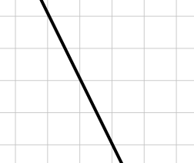 |  | 11 | The line joining $(-2, 7)$ and $(2, 1)$ |  | I | $$-1$$
 |  |  |  |  |  | J | $$-\frac{1}{2}$$
6 | 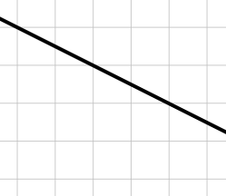 |  | 12 | The line joining $(-5, -2.5)$ and $(5, -6.5)$ |  | K | $$\frac{2}{3}$$
 |  |  |  |  |  | L | $$3$$

1 | 2 | 3 | 4 | 5 | 6 | 7 | 8 | 9 | 10 | 11 | 12

