Area and Perimeter Worded Problems

A farmer has a rectangular field of length 20 m and width 15 m. He wants to put a fence all the way around the outside of the field. Fencing is sold in 2 metre panels and costs £17.59 per panel. How much will it cost the farmer for his fence?

Colin has a circular pond of radius 1.3 metres. He wants to put an edging around the pond. Edging costs £12.99 per metre and is sold in one metre lengths. How much will it cost Colin to put the edging around his pond?

Layla has a semi-circular lawn with a diameter of 6.5 metres. She is going to spread fertilizer across all of the lawn. Fertilizer is sold in bags, and each bag covers an area of ${5 m}^{2}$. How many bags of fertilizer does Layla need?

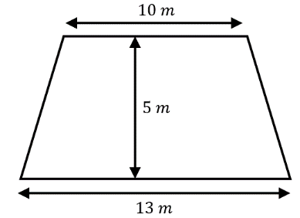
Jamal is going to paint his floor, which is in the shape of a trapezium. 1 litre of paint covers an area of $3 m^{2}$ and the paint is sold in 2 litre tins for £8.99. How much will it cost Jamal to paint his floor?

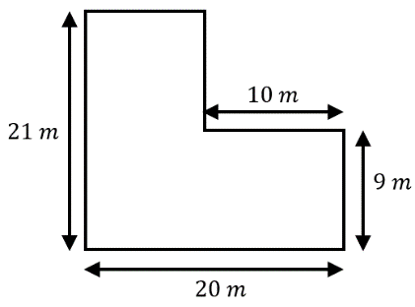
A school has an L-shaped playground, as shown. The caretaker is going to lay tarmac across the whole playground. Tarmac costs £3.12 per square metre. Work out the total cost of the tarmac the caretaker needs.

Area and Perimeter Worded Problems

A farmer has a rectangular field of length 20 m and width 15 m. He wants to put a fence all the way around the outside of the field. Fencing is sold in 2 metre panels and costs £17.59 per panel. How much will it cost the farmer for his fence?

Colin has a circular pond of radius 1.3 metres. He wants to put an edging around the pond. Edging costs £12.99 per metre and is sold in one metre lengths. How much will it cost Colin to put the edging around his pond?

Layla has a semi-circular lawn with a diameter of 6.5 metres. She is going to spread fertilizer across all of the lawn. Fertilizer is sold in bags, and each bag covers an area of ${5 m}^{2}$. How many bags of fertilizer does Layla need?

Jamal is going to paint his floor, which is in the shape of a trapezium. 1 litre of paint covers an area of $3 m^{2}$ and the paint is sold in 2 litre tins for £8.99. How much will it cost Jamal to paint his floor?

A school has an L-shaped playground, as shown. The caretaker is going to lay tarmac across the whole playground. Tarmac costs £3.12 per square metre. Work out the total cost of the tarmac the caretaker needs.

