Surface Areas of Cylinders, Cones and Spheres
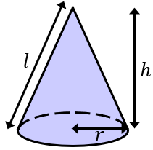  $$Curved Surface Area of Cone$$  $$=πrl$$ | 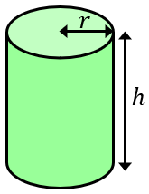  $$Curved Surface Area of Cylinder$$  $$=2πrh$$ |  | 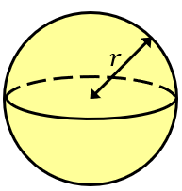  $$Surface Area of Sphere$$  $$=4πr^{2}$$
(a) | (b) |  | (c)
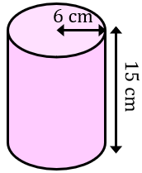  Find the curved surface area, giving your answer in terms of $π$ | 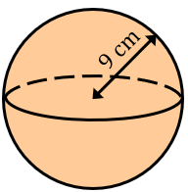  Find the surface area, giving your answer to 3 significant figures |  | 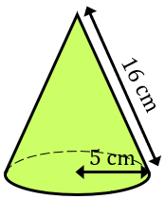  Find the curved surface area giving your answer to the nearest ${cm}^{2}$
(d) | (e) |  | (f)
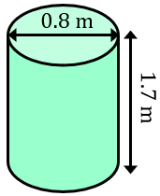  Find the total surface area, giving your answer to 2 decimal places | 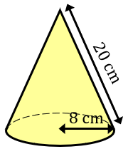  Find the total surface area, giving your answer to the nearest ${cm}^{2}$ |  | 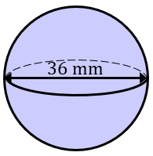  Find the surface area, leaving your answer in terms of $π$
(g) | (h) |  | (i)
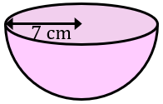  Find the total surface area of the hemisphere, leaving your answer in terms of $π$ | 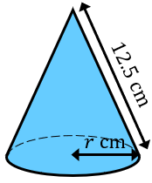  The cone has a curved surface area of $177 {cm}^{2}$. Find the radius $r$ to 1 decimal place. |  | 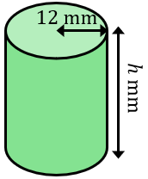  The total surface area is $744π {mm}^{2}.$Find the height of the cylinder.
(j) |  | (k)
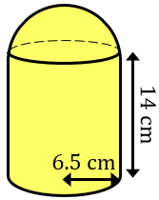  A shape is made by joining a hemisphere to a cylinder. Both have a radius of $6.5 cm$. Find the surface area of the compound shape to the nearest ${cm}^{2}$. |  | 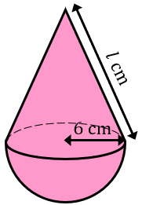  A shape is made by joining a cone to a hemisphere, where both shapes have the same radius. The total surface area is $246π {cm}^{2}$. Find the slanted height $l$ of the cone.

