Area of Rectangles and Squares

Find the area of the shapes on these ${cm}^{2}$ grids.
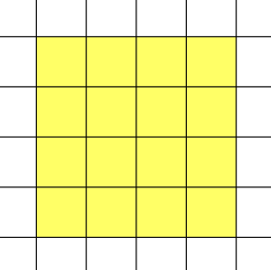
(a) (b)
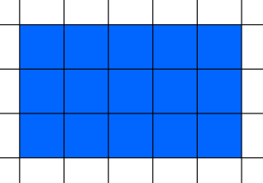

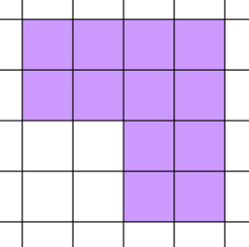
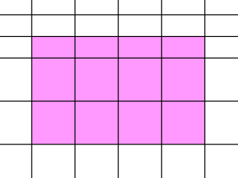
(c) (d)

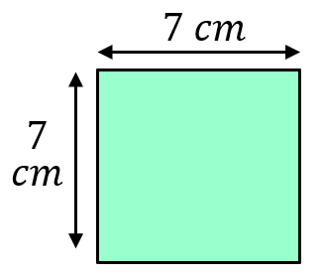
Find the area of each of these shapes.
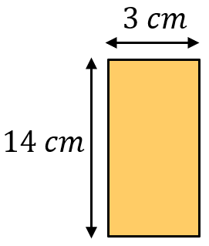
(a) (b)

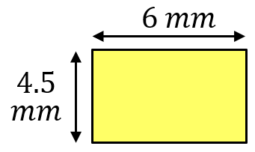
(c) (d)
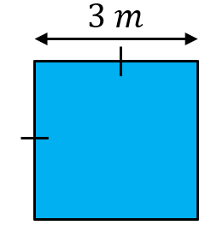

Given the area, find the missing length.
(a) $Area=60 {cm}^{2}$ (b) $Area=27.5 {mm}^{2}$
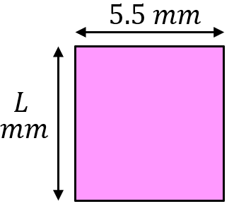
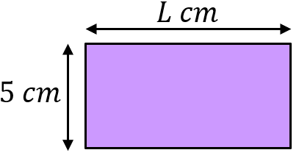

A rectangle has an area of $42 {cm}^{2}$. Find as many possible pairs of lengths and widths as you can.
Area of Rectangles and Squares

Find the area of the shapes on these ${cm}^{2}$ grids.
(a) (b)

(c) (d)

Find the area of each of these shapes.
(a) (b)

(c) (d)

Given the area, find the missing length.
(a) $Area=60 {cm}^{2}$ (b) $Area=27.5 {mm}^{2}$

A rectangle has an area of $42 {cm}^{2}$. Find as many possible pairs of lengths and widths as you can.

