Investigating Right-Angled Triangles
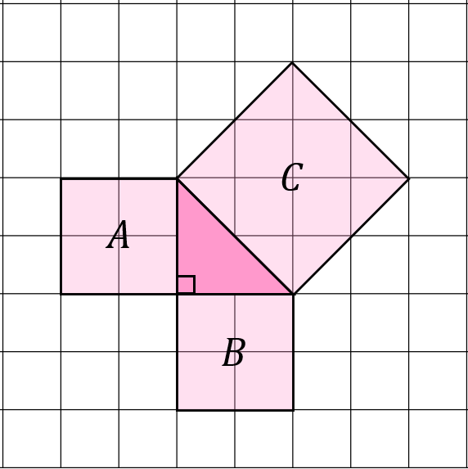
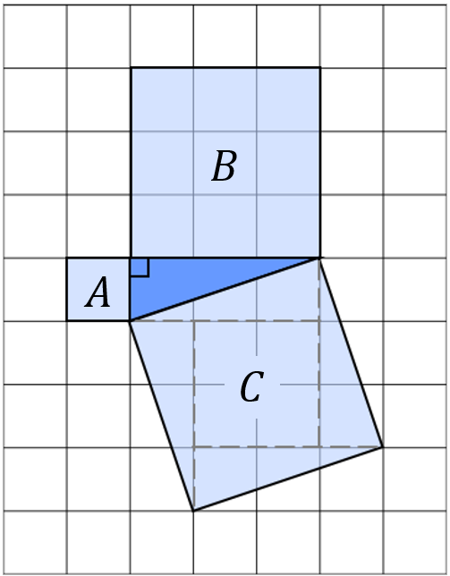
For each of the following right-angled triangles, find the areas of the squares attached to each of the sides.

Triangle | Area $A$ | Area $B$ | Area$C$
Pink
Blue
Green
Yellow

What do you notice? _____________________________
______________________________________________
