Reading Distance-Time Graphs
(a) | (b) | (c)
The distance-time graph shows Jamil’s journey as he goes to visit a friend. | The travel graph shows Natalie’s journey as she goes for a walk. | The graph shows the journey of two runners, Pol and Pat, during a 20 km race.
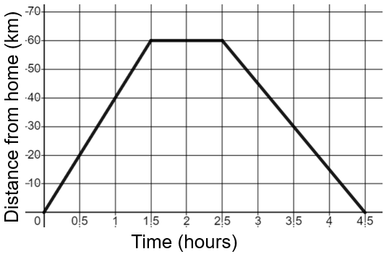 | 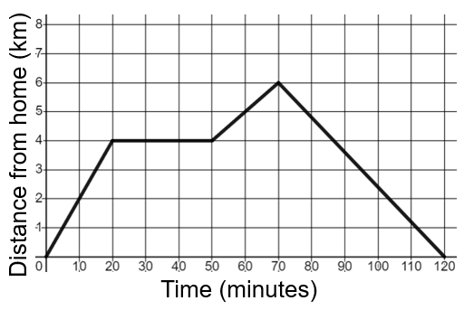 | 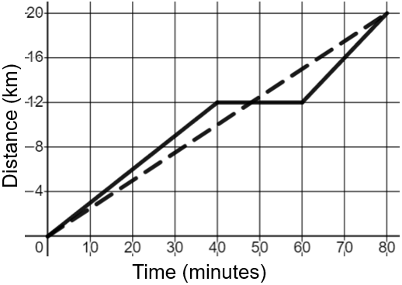
(a) How long after Jamil has set off from home does he stop to visit his friend?  (b) Calculate Jamil’s speed as he travels to his friend’s house.  (c) How long does Jamil stay at his friend’s house?  (d) Calculate the speed Jamil travels at as he returns home. | (a) Natalie sets off from home and arrives at her friend’s house 20 minutes later. How long does Natalie stay at her friend’s house?  (b) Natalie then walks for a further 20 minutes to the post box, before returning home. How far does she walk in total?  (c) Calculate Natalie’s speed in km/h as she walks home from the post box. | (a) Pol runs the race at a constant speed over 80 minutes. Calculate Pol’s speed in km/h.  (b) Describe Pat’s run, calculating any speeds in km/h.  (c) Pol runs past Pat 12 km into the race. At what time does this happen?

