Statistics and Probability Revision |  |  |  | 4
(a) | (b) | (c)
The table shows the probability of a child having different coloured eyes.  Blue Brown Green Grey  0.15 0.37  The probability of having green eyes is three times the probability of having grey eyes. Complete the table. | Seher has a biased six-sided dice. When rolled, the probability of the dice landing on a four is $0.35$. Seher is going to roll the dice $500$ times. Work out an estimate of the number of times it will land on a four. | The Venn diagram shows the numbers in each of the sets $C$ and $D$ and the universal set.
 |  | 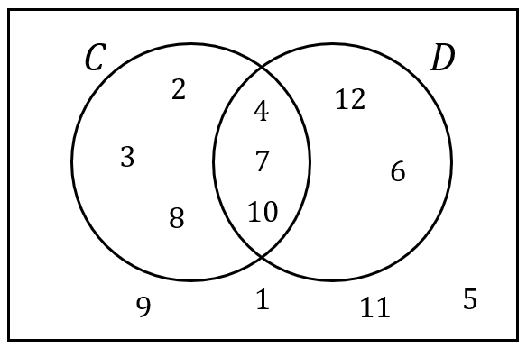 | (i) List the members of $C∪D$  (ii) List the members of $C'$  (iii) List the members of $C∩D'$
(d) | (e) | (f)
Six numbers  $$4 x x 9 11 y$$  are written in order of size. The numbers have a median of $7.5$ and a mean of $8$. Find the values of $x$ and $y$. | A bag contains red, white and black counters. There are $x$ red counters, $2x$ white counters and 6 black counters. When a counter is picked at random from the bag, the probability that it is a black counter is $\frac{1}{5}$. Find the value of $x$. | Class 7A has 20 students and class 7B has 24 students. Both classes sat a History test. The mean score in 7A was 70.2 and the mean score in 7B was 73.25. Find the mean test score across both classes, giving your answer correct to 1 decimal place.

