Angles in Parallel Lines

State whether each pair of shaded angles is alternate, corresponding or co-interior.
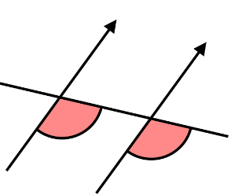
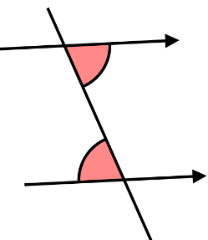
(a) (b)

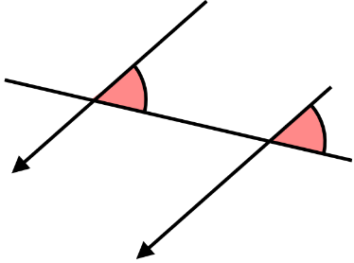
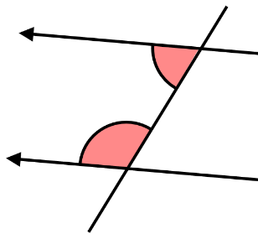
(c) (d)

Using the diagram below, write down all the pairs of
(a) alternate angles
(b) corresponding angles
(c) co-interior angles
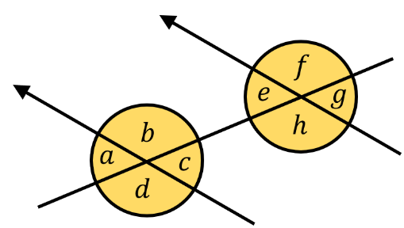

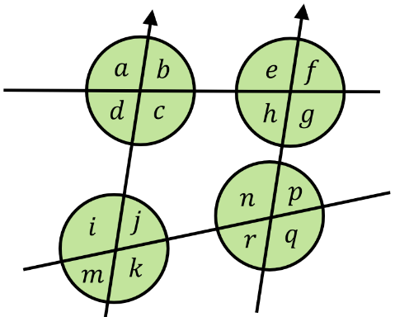
Decide whether each of these statements are true or false.

(a) $c$ and $h$ are co-interior angles
(b) $c$ and $k$ are corresponding angles
(c) $d$ and $i$ are co-interior angles
(d) $j$ and $r$are alternate angles
(e) $h$ and $n$ are co-interior angles
(f) $h$ and $p$ are alternate angles
(g) $j$ and $p$ are corresponding angles
Angles in Parallel Lines

State whether each pair of shaded angles is alternate, corresponding or co-interior.
(a) (b)

(c) (d)

Using the diagram below, write down all the pairs of
(a) alternate angles
(b) corresponding angles
(c) co-interior angles

Decide whether each of these statements are true or false.

(a) $c$ and $h$ are co-interior angles
(b) $c$ and $k$ are corresponding angles
(c) $d$ and $i$ are co-interior angles
(d) $j$ and $r$are alternate angles
(e) $h$ and $n$ are co-interior angles
(f) $h$ and $p$ are alternate angles
(g) $j$ and $p$ are corresponding angles

