Adding and Subtracting Surds

Work out:
(a) $4\sqrt{2}+3\sqrt{2}$ (b) $10\sqrt{3}-2\sqrt{3}$
(c) $-3\sqrt{5}+7\sqrt{5}$ (d) $6\sqrt{2}-8\sqrt{2}$
(e) $4\sqrt{3}+7\sqrt{3}-\sqrt{3}$
(f) $2\sqrt{7}+5\sqrt{7}-8\sqrt{7}$
(g) $\frac{3}{2}\sqrt{5}+\frac{7}{2}\sqrt{5}-\frac{1}{2}\sqrt{5}$

Express as a single surd:
(a) $3\sqrt{2}+\sqrt{8}$ (b) $\sqrt{40}+\sqrt{10}$
(c) $6\sqrt{5}-\sqrt{20}$ (d) $-2\sqrt{3}+\sqrt{48}$
(e) $\sqrt{8}+\sqrt{32}-10\sqrt{2}$
(f) $5\sqrt{3}-\sqrt{3}+2\sqrt{12}$
(g) $-3\sqrt{10}-\sqrt{90}-2\sqrt{160}$

Simplify:
(a) $5+2\sqrt{3}+13+5\sqrt{3}$
(b) $5\sqrt{2}-3-2\sqrt{2}+11$
(c) $2\sqrt{3}+3\sqrt{2}+6\sqrt{3}-\sqrt{2}$
(d) $3\sqrt{5}-\sqrt{10}-6\sqrt{10}-\sqrt{5}$
(e) $\sqrt{8}+\sqrt{20}+6\sqrt{2}+3\sqrt{5}$
(f) $\sqrt{200}-3\sqrt{6}+6\sqrt{2}-\sqrt{486}$

Find the values of $x$ and $y$ and the perimeter of the compound shape in the form $a\sqrt{3}+b\sqrt{5}$.
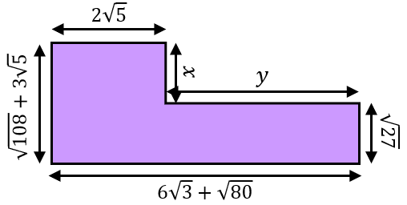

Adding and Subtracting Surds

Work out:
(a) $4\sqrt{2}+3\sqrt{2}$ (b) $10\sqrt{3}-2\sqrt{3}$
(c) $-3\sqrt{5}+7\sqrt{5}$ (d) $6\sqrt{2}-8\sqrt{2}$
(e) $4\sqrt{3}+7\sqrt{3}-\sqrt{3}$
(f) $2\sqrt{7}+5\sqrt{7}-8\sqrt{7}$
(g) $\frac{3}{2}\sqrt{5}+\frac{7}{2}\sqrt{5}-\frac{1}{2}\sqrt{5}$

Express as a single surd:
(a) $3\sqrt{2}+\sqrt{8}$ (b) $\sqrt{40}+\sqrt{10}$
(c) $6\sqrt{5}-\sqrt{20}$ (d) $-2\sqrt{3}+\sqrt{48}$
(e) $\sqrt{8}+\sqrt{32}-10\sqrt{2}$
(f) $5\sqrt{3}-\sqrt{3}+2\sqrt{12}$
(g) $-3\sqrt{10}-\sqrt{90}-2\sqrt{160}$

Simplify:
(a) $5+2\sqrt{3}+13+5\sqrt{3}$
(b) $5\sqrt{2}-3-2\sqrt{2}+11$
(c) $2\sqrt{3}+3\sqrt{2}+6\sqrt{3}-\sqrt{2}$
(d) $3\sqrt{5}-\sqrt{10}-6\sqrt{10}-\sqrt{5}$
(e) $\sqrt{8}+\sqrt{20}+6\sqrt{2}+3\sqrt{5}$
(f) $\sqrt{200}-3\sqrt{6}+6\sqrt{2}-\sqrt{486}$

Find the values of $x$ and $y$ and the perimeter of the compound shape in the form $a\sqrt{3}+b\sqrt{5}$.

