Properties of 3D Shapes

For each of the 3D shapes shown, write down the number of faces, vertices and edges.
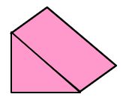
(a) (b)

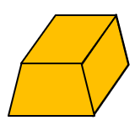
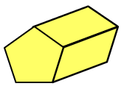
(c) (d)

Complete the table for the 3D shapes.

3D Shape | Faces | Vertices | Edges
Cube
Hexagonal Prism
Square-based Pyramid
Tetrahedron
Octahedron

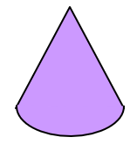
For each shape shown, write down the number of flat faces, curved surfaces, edges and vertices.
(a) (b)

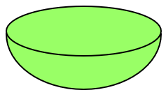
(c) (d)

Properties of 3D Shapes

For each of the 3D shapes shown, write down the number of faces, vertices and edges.
(a) (b)

(c) (d)

Complete the table for the 3D shapes.

3D Shape | Faces | Vertices | Edges
Cube
Hexagonal Prism
Square-based Pyramid
Tetrahedron
Octahedron

For each shape shown, write down the number of flat faces, curved surfaces, edges and vertices.
(a) (b)

(c) (d)

