Converting Metric Units of Speed
(a) | (b) | (c) | (d)
Convert$54$ km/h to m/s  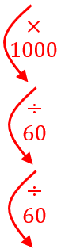 $54$ km $1$ hour  $54000$ m $1$ hour  $900$ m $1$ minute  $15$ m $1$ second | Convert $90$ km/h to m/s  $90$ km $1$ hour  $90000$ m $1$ hour  $1$ minute  $1$ second | Convert $45$ km/h to m/s  $45$ km $1$ hour  $1$ hour  $1$ minute  $1$ second | Convert $126$ km/h to m/s  $126$ km $1$ hour
(e) | (f) | (g) | (h)
Convert$10$ m/s to km/h  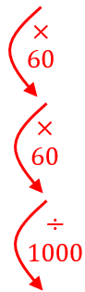 $10$ m $1$ second 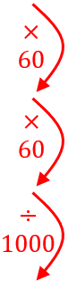  $600$ m $1$ minute  $36000$ m $1$ hour  $36$ km $1$ hour | Convert $2.5$ m/s to km/h  2.5 m 1 second  150 m 1 minute  1 hour  1 hour | Convert $30$ m/s to km/h  $30$ m $1$ second  $1$ minute  $1$ hour  $1$ hour | Convert $7.5$ m/s to km/h  $7.5$ m $1$ second
(i) |  | (j)
A car is travelling at $14$ m/s. The speed limit is $50$ km/h. Is the car breaking the speed limit? You must show your working. |  | A lorry travels at $x$ km/h. Find an expression for the speed of the motorbike in metres per second.

