Plotting Reciprocal Graphs
(a) | (b) | (c)
Plot the graph of $y=\frac{2}{x}$  from $x=-4$ to $x=4$ | Plot the graph of $y=-\frac{5}{x}$  from $x=-5$ to $x=5$ | Plot the graph of $y=\frac{10}{x^{2}}$  from $x=-2$ to $x=3$
$$x$$ $$-4$$ $$-2$$ $$-1$$ $$0$$ $$1$$ $$2$$ $$4$$  $$y$$ | $$x$$ $$-5$$ $$-2$$ $$-1$$ $$0$$ $$1$$ $$2$$ $$5$$  $$y$$ | $$x$$ $$-5$$ $$-2$$ $$-1$$ $$0$$ $$1$$ $$2$$ $$5$$  $$y$$
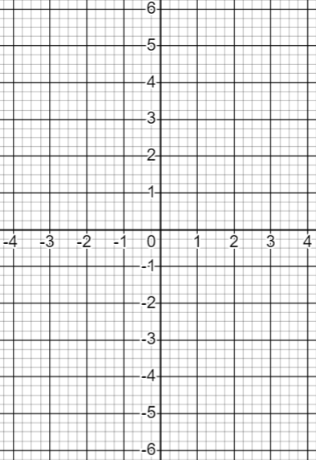 | 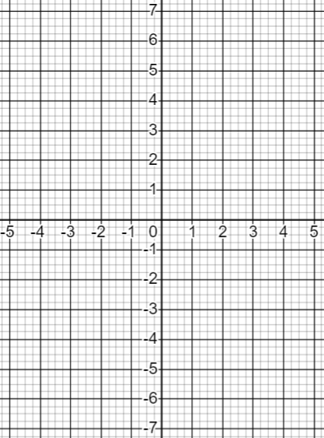 | 