Fill in the Blanks | Area of a Sector

Radius | Angle | Fraction | Area
$$8 cm$$ | $$90°$$ | $$\frac{90}{360}=\frac{1}{4}$$ | $$\frac{90}{360}×π×8^{2}=50.3 {cm}^{2}$$
$$7 cm$$ | $$45°$$ | $$\frac{45}{360}=\frac{1}{8}$$
$$15 mm$$ | $$60°$$
$$4 cm$$ | $$75°$$
$$1.8 m$$ | $$130°$$
$$82 mm$$ | $$335°$$
$$11 cm$$ | $$275°$$
$$9 mm$$ |  | 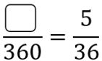
$$10 cm$$ |  | 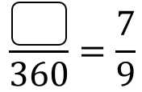
$$25 mm$$ |  |  | 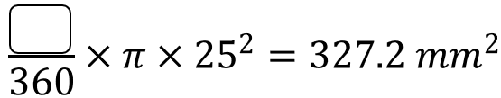
$$2 m$$ |  |  | 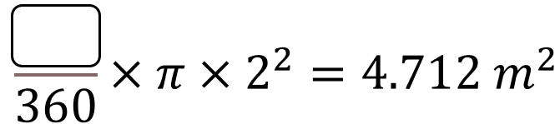
 | $$35°$$ |  | 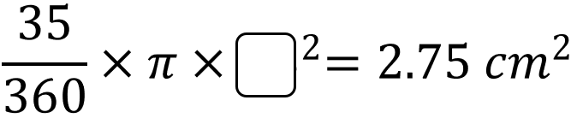
 | $$315°$$ |  | 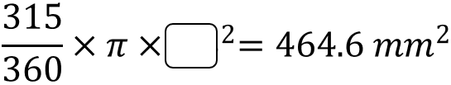
 | $$58°$$ |  | 