Angles in Quadrilaterals

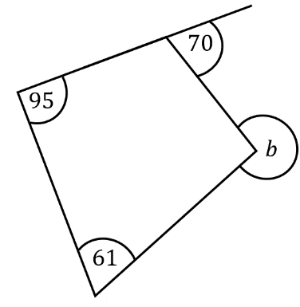
Find the missing angles.
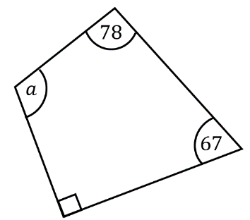
(a) (b)

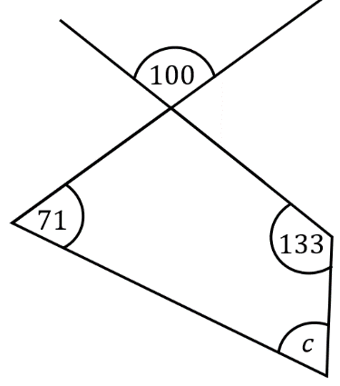
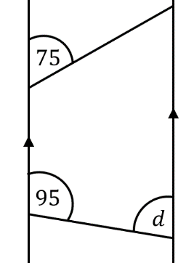
(c) (d)

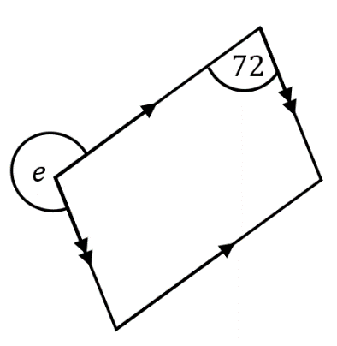
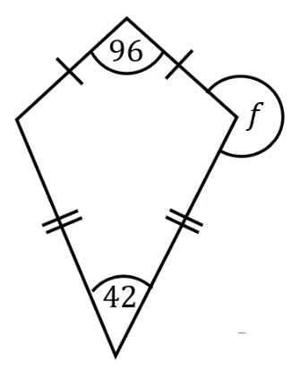
Find the missing angles in these special quadrilaterals.
(e) (f)

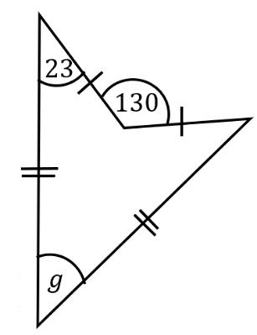

(g)

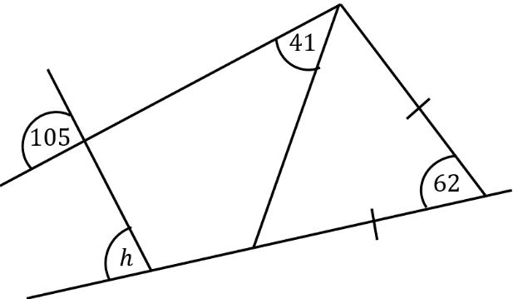
Find the missing angle.
(h)

Angles in Quadrilaterals

Find the missing angles.
(a) (b)

(c) (d)

Find the missing angles in these special quadrilaterals.
(e) (f)

(g)

Find the missing angle.
(h)

