Match-Up | Measuring Bearings

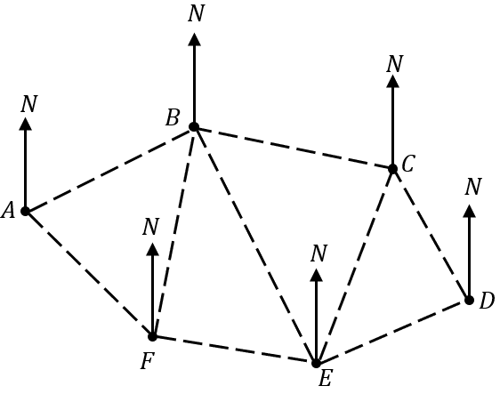 | A | $$150$$
 | B | $$280$$
 | C | $$135$$
 | D | $$201$$
 | E | $$247$$
 | F | $$100$$
 | G | $$065$$
 | H | $$332$$
 | I | $$191$$
 | J | $$102$$

1 | Find the bearing of $B$ from $A$ | 6 | Find the bearing of $F$ from $B$
2 | Find the bearing of $F$ from $A$ | 7 | Find the bearing of $E$ from $C$
3 | Find the bearing of $C$ from $B$ | 8 | Find the bearing of $F$ from $E$
4 | Find the bearing of $D$ from $C$ | 9 | Find the bearing of $B$ from $E$
5 | Find the bearing of $E$ from $F$ | 10 | Find the bearing of $E$ from $D$

1 | 2 | 3 | 4 | 5 | 6 | 7 | 8 | 9 | 10

