Drawing Transformations of Graphs
(a) | (b)
Here is a graph of $y=f(x)$. On the same axes, draw the graph of $y=f\left(x\right)-2$.  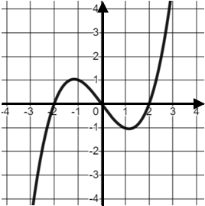 | Here is a graph of $y=f(x)$. On the same axes, draw the graph of $y=-f\left(x\right)$  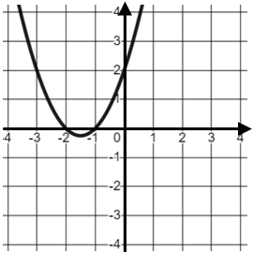
(c) | (d)
Here is a graph of $y=f(x)$. On the same axes, draw the graph of $y=3f(x)$  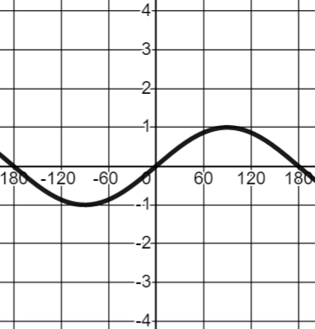 | Here is a graph of $y=f(x)$. On the same axes, draw the graph of $y=f\left(x+1\right)$  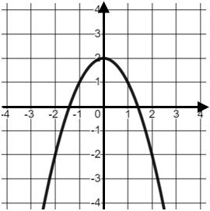
(e) | (f)
Here is a graph of $y=f(x)$. On the same axes, draw the graph of $y=f(2x)$  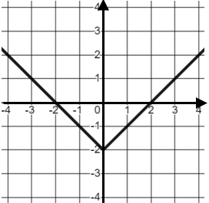 | Here is a graph of $y=f(x)$. On the same axes, draw the graph of $y=2f\left(x\right)-1$  