Tree Diagrams for Dependent Events

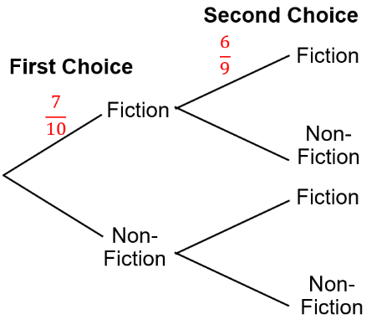
A bookshelf contains three non-fiction books and seven fiction books. Bob chooses two books at random. Complete the tree diagram.

Find the probability that Bob chooses two non-fiction books.

A drawer contains five red socks and three black socks. A sock is taken out at random and not replaced. A second sock is then taken out. Draw a tree diagram and calculate the probability that either a pair of red socks or a pair of black socks is chosen.

A bag contains 4 yellow balls and 6 green balls. A ball is taken from the bag and not replaced. A second ball is then taken. Draw a tree diagram and find the probability that the two balls are different colours.

Amir has a biscuit tin containing 3 bourbons and 5 custard creams. He chooses a biscuit at random, eats it, then chooses another and eats that too. Draw a tree diagram and use it to find the probability that Amir has eaten at least one custard cream.

In a zoo, there are four elephants, three tigers and two giraffes. The zookeeper wants to choose two animals at random to take part in a promotional photo. Draw a tree diagram and use it to find the probability that the zookeeper chooses two of the same animal.
Tree Diagrams for Dependent Events

A bookshelf contains three non-fiction books and seven fiction books. Bob chooses two books at random. Complete the tree diagram.

Find the probability that Bob chooses two non-fiction books.

A drawer contains five red socks and three black socks. A sock is taken out at random and not replaced. A second sock is then taken out. Draw a tree diagram and calculate the probability that either a pair of red socks or a pair of black socks is chosen.

A bag contains 4 yellow balls and 6 green balls. A ball is taken from the bag and not replaced. A second ball is then taken. Draw a tree diagram and find the probability that the two balls are different colours.

Amir has a biscuit tin containing 3 bourbons and 5 custard creams. He chooses a biscuit at random, eats it, then chooses another and eats that too. Draw a tree diagram and use it to find the probability that Amir has eaten at least one custard cream.

In a zoo, there are four elephants, three tigers and two giraffes. The zookeeper wants to choose two animals at random to take part in a promotional photo. Draw a tree diagram and use it to find the probability that the zookeeper chooses two of the same animal.

