Tree Diagrams Revision
(a) | (b) | (c)
Allie and Alex play two games of tennis. The probability of Allie winning the game is 0.45.  (a) Complete the tree diagram.  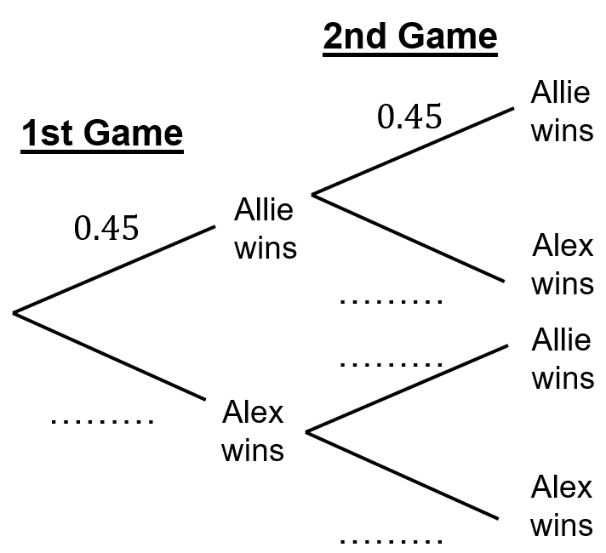  (b) Find the probability that Alex wins both matches.  (c) Find the probability that Allie and Alex win one match each. | Yusuf spins two fair spinners, A and B. Spinner A can land on a 1, 2 or 3. Spinner B can land on a 2, 3 or 4.  (a) Draw a tree diagram.  (b) Find the probability that the total on the spinners is an odd number. | There are 10 biscuits in a tin. 7 are digestives and 3 are bourbons. Temi takes a biscuit at random from the tin and eats it. She does this two more times. Calculate the probability that she has eaten at least two digestives.

