Mixed Sine and Cosine Rule

Find the missing length or angle.

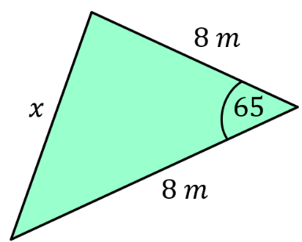
(a)

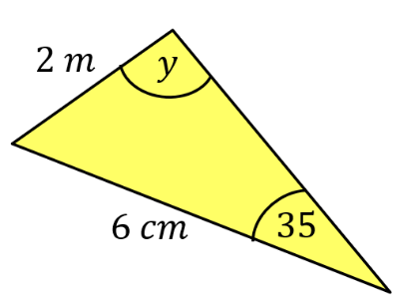
$$4 cm$$

(b)

Find the area of the segment.
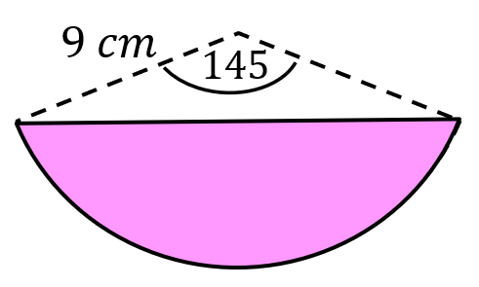
(c)

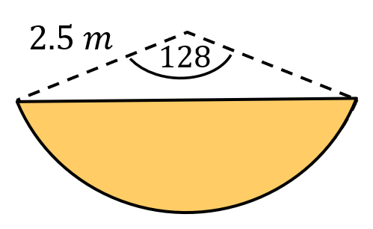

(d)

Find the perimeter of these shapes.
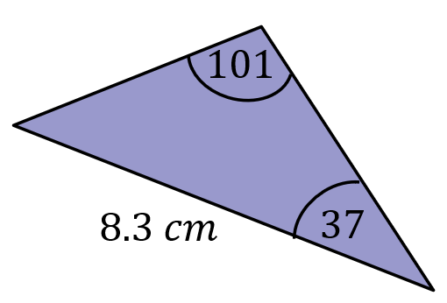
(e)

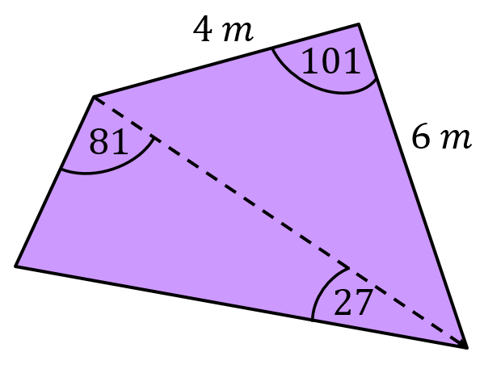
(f)

(g) The hands of a clock have lengths 8cm and 10 cm. The time on the clock is 5 o’clock. Find the distance between the tips of the two hands.
Mixed Sine and Cosine Rule

Find the missing length or angle.
(a)

$$4 cm$$

(b)

Find the area of the segment.
(c)

(d)

Find the perimeter of these shapes.
(e)

(f)

(g) The hands of a clock have lengths 8cm and 10 cm. The time on the clock is 5 o’clock. Find the distance between the tips of the two hands.

