Constructing a Regular Pentagon
For this construction you will need to work on a piece of A4 paper in portrait.
Step 1 – Draw a horizontal line halfway down your paper. Mark a point halfway along the line. | Step 2 – Draw a circle of radius 6 cm. | Step 3 – Keeping the compasses at 6 cm, put the compass point on A and mark arcs above and below on the circumference. Repeat at B.  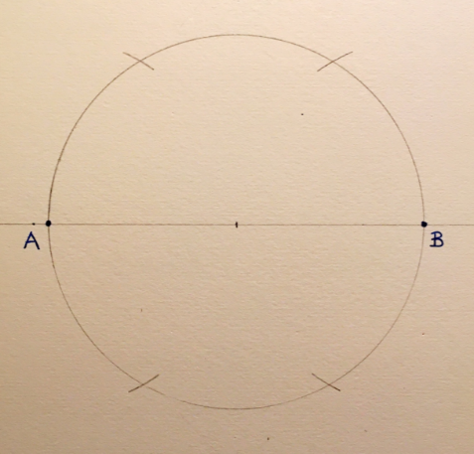
Step 4 – Construct the perpendicular bisector of the line AB.  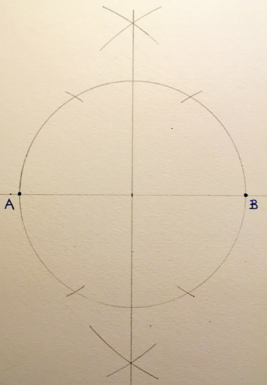 | Step 5 – Join the two arcs on the right-hand side of the circle.  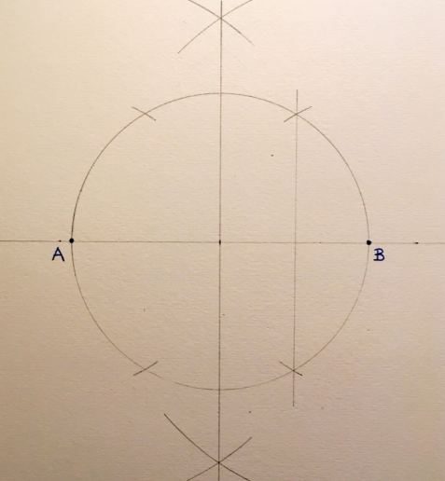 | Step 6 – Place your compass point on the red point, open your compasses to the blue point and draw an arc downwards.  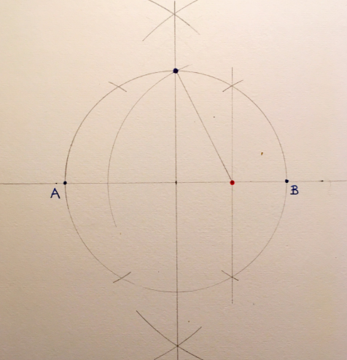
Step 7 – Place the compass point on the blue point and open your compasses to the second red point. Step this radius around the circle, marking with small arcs.  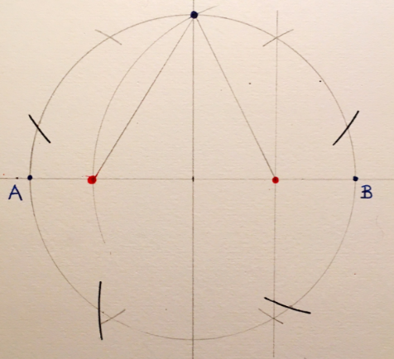 | Step 8 – Using a ruler, join each point where the arcs cross the circumference to the next.  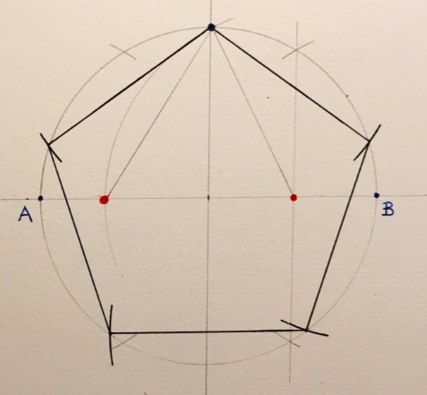 | Step 9 – Colour your pentagon using pencil crayons or fineliners!  