Trigonometry Revision
(a) | (b) |  | (c) |  | (d)
Find the value of $x$, to 1 decimal place.  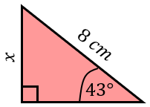 | Find the value of $y$ to 3 significant figures.  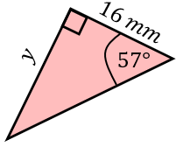 |  | Find angle $x$, to 1 decimal place.  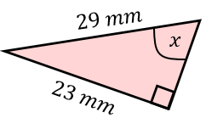 |  | Find the value of $a$, to 1 decimal place.  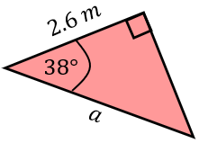
(e) | (f) |  | (g) |  | (h)
Find angle $ACB$ to 3 significant figures.  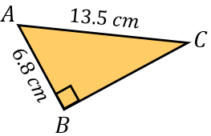 | Find the perimeter of the triangle to 1 decimal place.  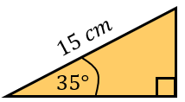 |  | Find angle $x$ to 3 significant figures.  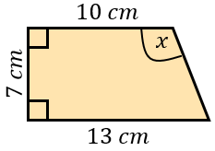 |  | Find the area of the isosceles triangle to 1 decimal place.  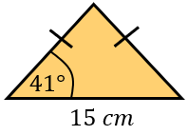
(i) |  | (j) |  | (k)
Find the length $x$ to 3 significant figures.  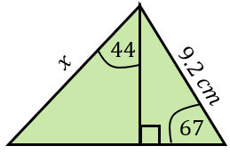 |  | Find the value of $x$, giving your answer to 3 significant figures.  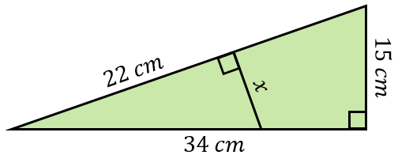 |  | Find the exact value of $x$.  