Histograms
(a) | (b)
The distance travelled to work by 50 employees is recorded in a grouped frequency table.  (a) Calculate the frequency density for each class.  Distance (km) Frequency  $$0<d≤5$$ 12  $$5<h≤10$$ 16  $$10<h≤20$$ 10  $$20<h≤30$$ 7  $$30<h≤50$$ 5  (b) Plot a histogram.  (c) Use your histogram to estimate the number of people who travel at least 12 km to work.  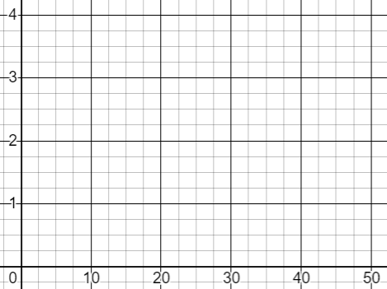 | The house prices of 100 houses in a village are recorded in a grouped frequency table.  (a) Use the information in the table to calculate frequency densities and plot a histogram.  (b) Use your histogram to estimate the percentage of houses that cost less than $£270 000$. | House Price ($£ thousands)$ Frequency  $$0<p≤100$$ 6  $$100<p≤200$$ 22  $$200<p≤250$$ 18  $$250<p≤300$$ 35  $$300<p≤500$$ 15  $$500<p≤1000$$ 4
 | (c)
 | The time taken, in minutes, by 50 students to solve a maths puzzle is recorded in a grouped frequency table.  (a) Plot a histogram to represent this data.  (b) Use your histogram to find the median time taken. | Time Taken (minutes$)$ Frequency  $$0<t≤2$$ 4  $$2<t≤4$$ 7  $$4<t≤5$$ 10  $$5<t≤6$$ 12  $$6<t≤7$$ 11  $$7<t≤12$$ 6

