Two Set Practical Problems
A garage has 50 cars for sale. 15 of the cars have both air conditioning and cruise control. 31 of the cars have air conditioning. 17 of the cars have cruise control. Draw a Venn diagram to represent this information.
(a) How many cars do not have air conditioning or cruise control?
(b) How many cars have air conditioning but not cruise control?

90 people in a sports club were surveyed. 19 play tennis and squash. 50 play tennis. 32 play squash. Draw a Venn diagram to represent this information.
(a) How many people do not play squash, but do play tennis?
(b) How many people play neither squash nor tennis?

There are 16 people in a queue. Two are wearing both a hat and a scarf. Eight are wearing a hat. Seven are wearing neither a hat nor a scarf. Draw a Venn diagram to represent this information.
(a) How many people are wearing a scarf?
(b) How many people are wearing either a hat or a scarf or both?

The Venn shows how many students in a class play football (F) or hockey (H).
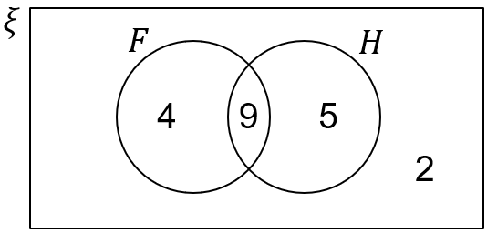
(a) How many students play both sports?
(b) Write down $n\left(H^{'}\right)$
(c) Write down $n(F^{'}∩H)$
Two Set Practical Problems
A garage has 50 cars for sale. 15 of the cars have both air conditioning and cruise control. 31 of the cars have air conditioning. 17 of the cars have cruise control. Draw a Venn diagram to represent this information.
(a) How many cars do not have air conditioning or cruise control?
(b) How many cars have air conditioning but not cruise control?

90 people in a sports club were surveyed. 19 play tennis and squash. 50 play tennis. 32 play squash. Draw a Venn diagram to represent this information.
(a) How many people do not play squash, but do play tennis?
(b) How many people play neither squash nor tennis?

There are 16 people in a queue. Two are wearing both a hat and a scarf. Eight are wearing a hat. Seven are wearing neither a hat nor a scarf. Draw a Venn diagram to represent this information.
(a) How many people are wearing a scarf?
(b) How many people are wearing either a hat or a scarf or both?

The Venn shows how many students in a class play football (F) or hockey (H).
(a) How many students play both sports?
(b) Write down $n\left(H^{'}\right)$
(c) Write down $n(F^{'}∩H)$

